Data Engineering END TO END Project

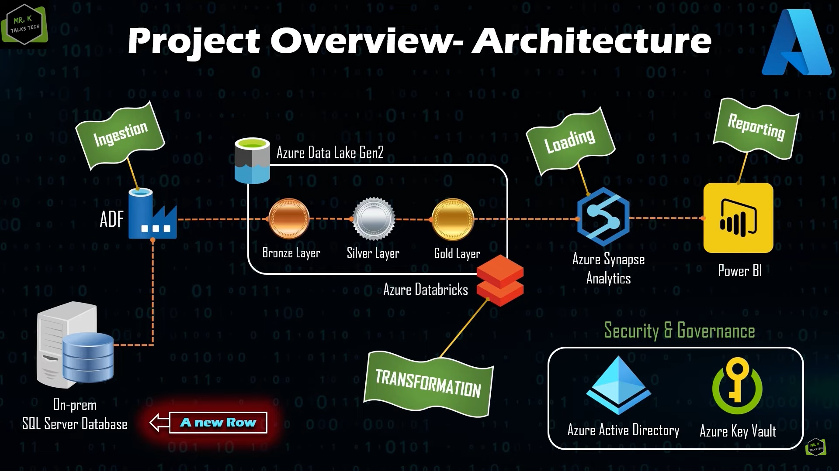

The above Architecture is implemented in this project where we load data from on premises sql server and perform some transformation and load in to synapse for reporting purpose

Step1)

Environement setup

Create sAzure data factory

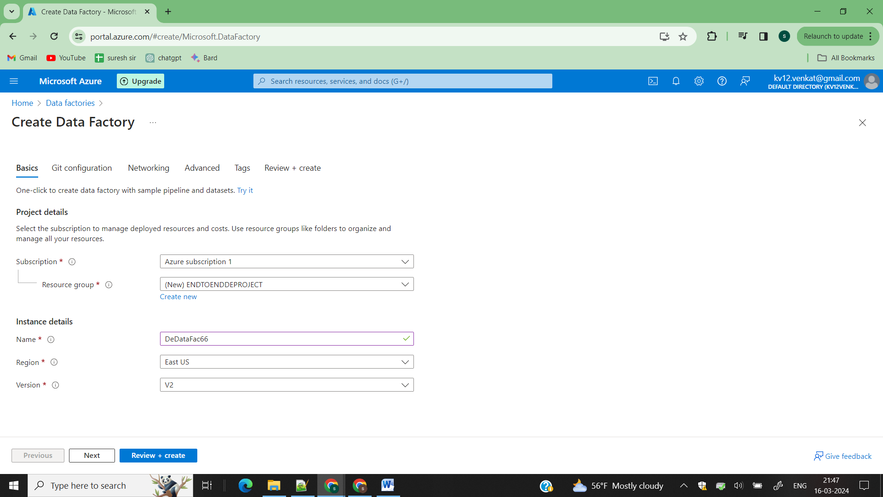

Search datafactories and click on Create after filling above details

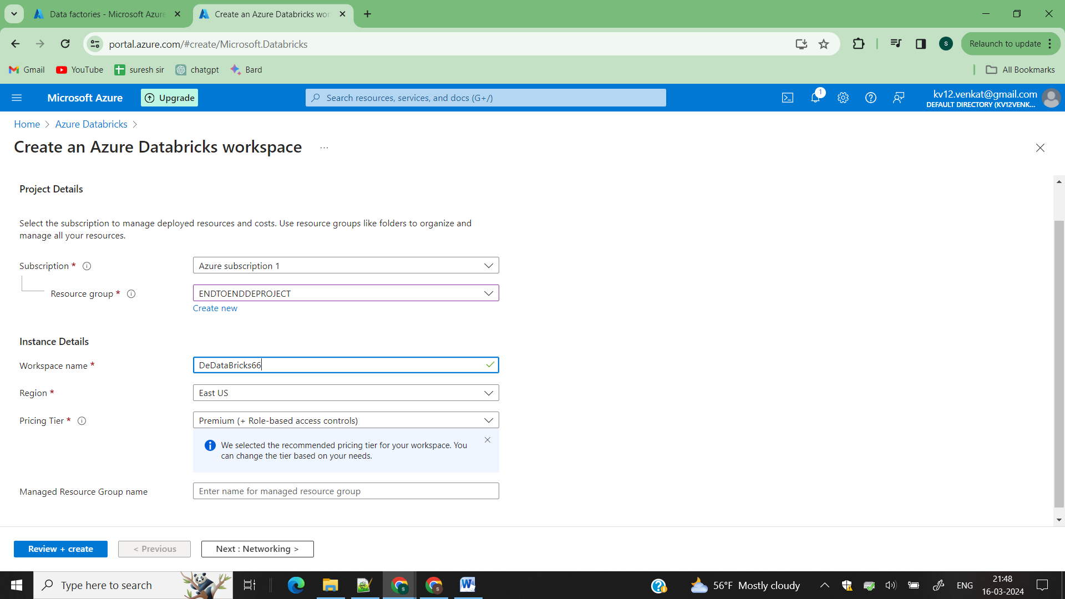

Search databricks and click on Create after filling above details

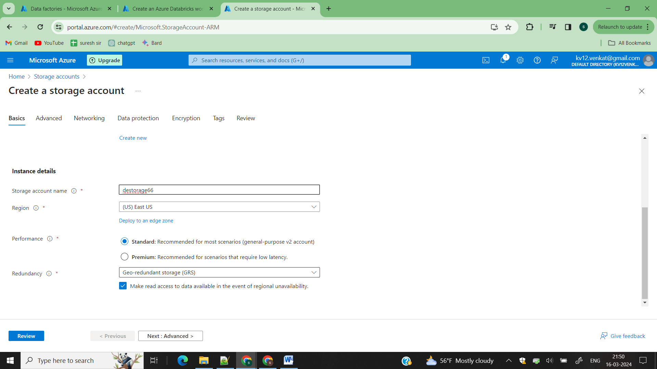

Create adls storage account

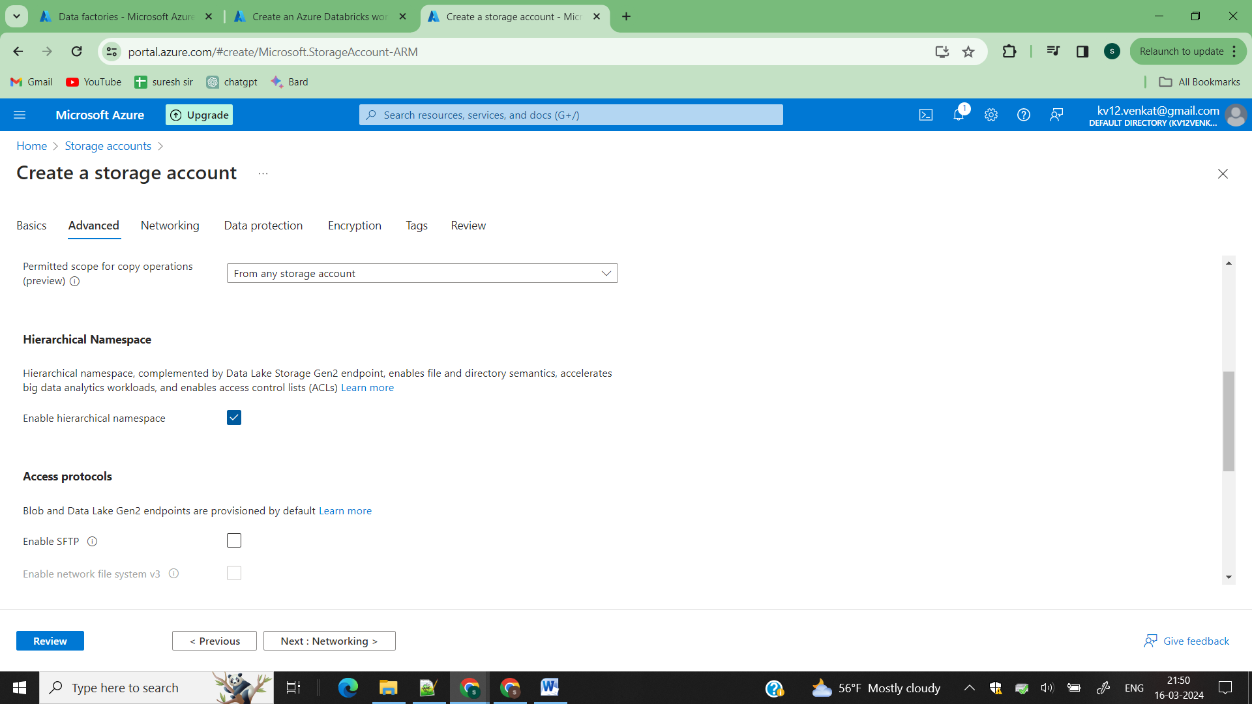

In Advance section click on this check button then only it is considered has ADLS2 then click on create

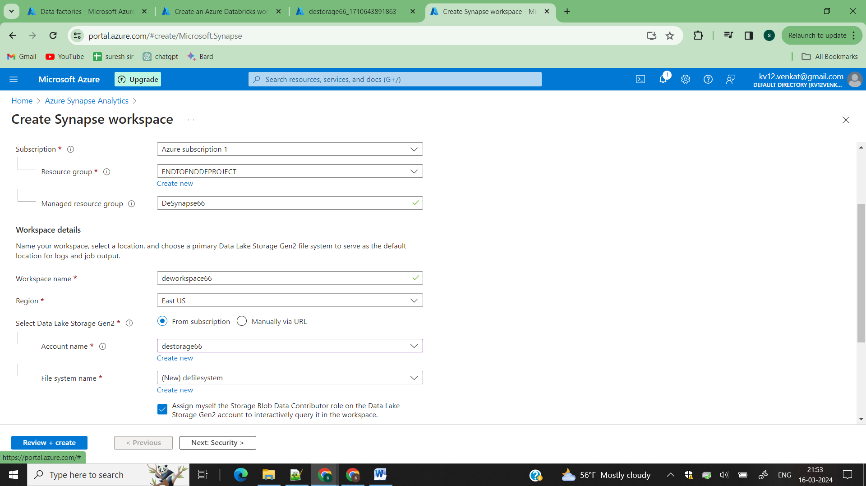

Search for Azure synapse analytics and configure your ADLS storage account with your synapse and then click on create

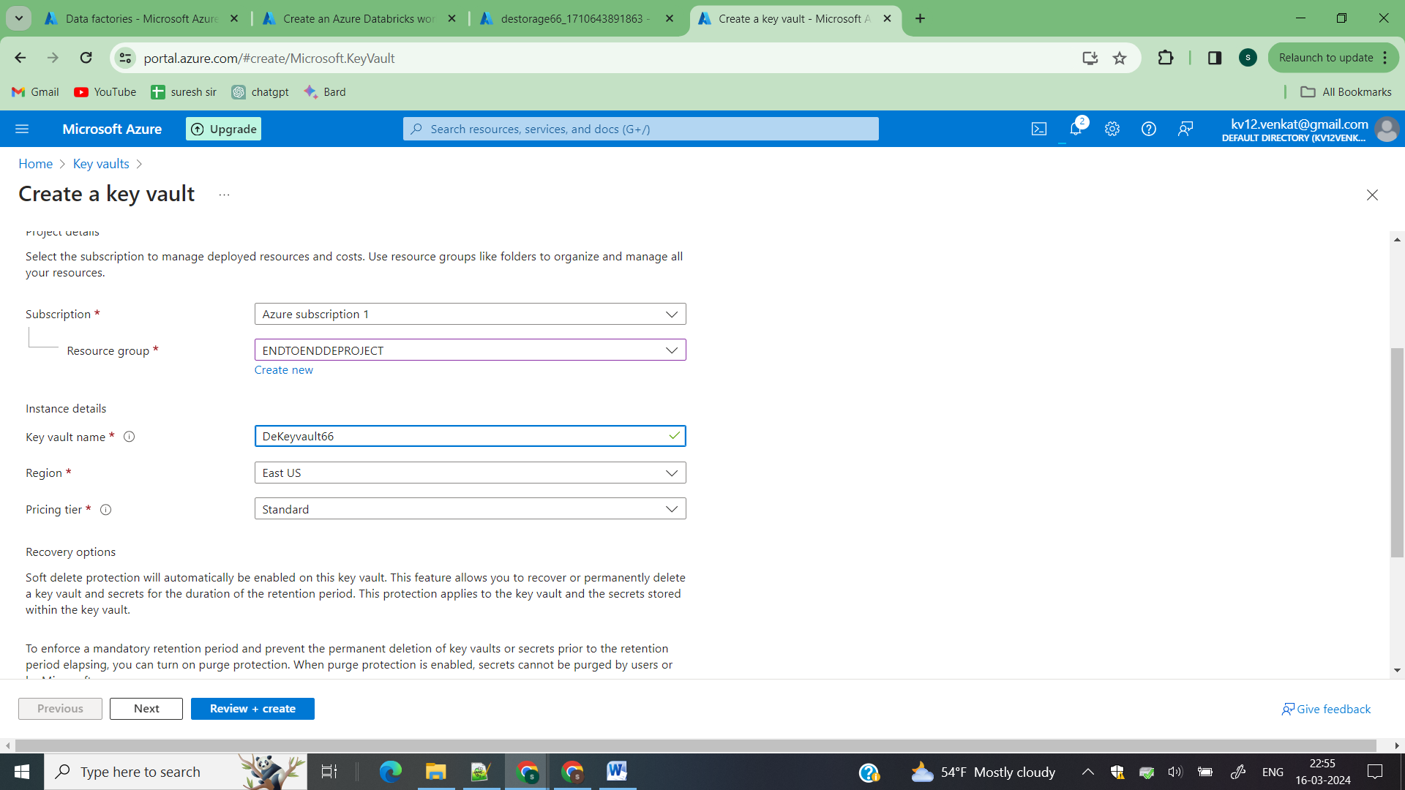

Create Azure key vault with to store your secrets

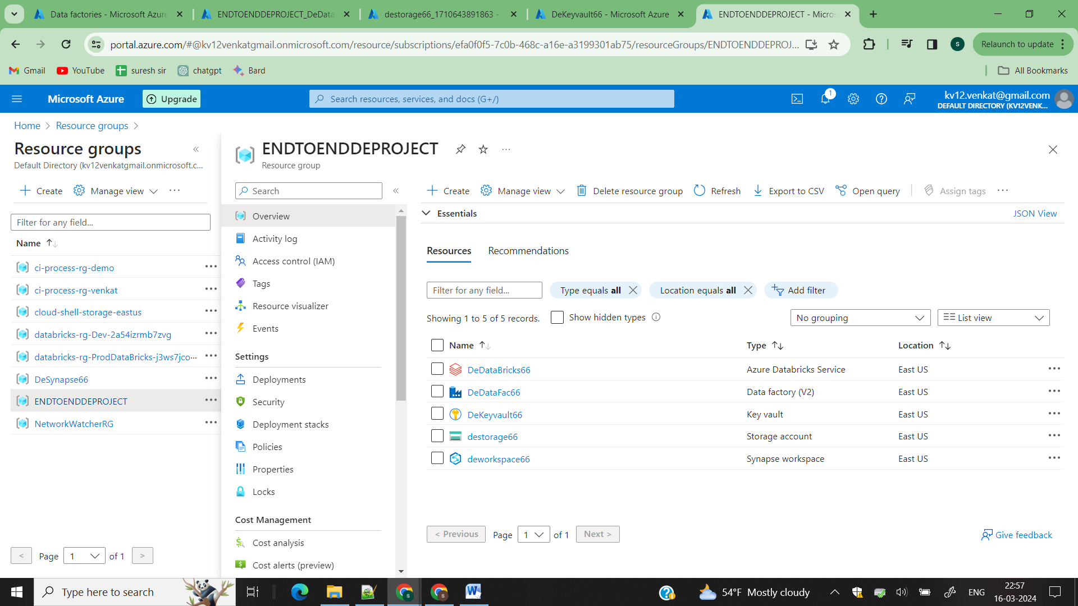

Make sure all your services are created under your service group

Open Your sql server in your local system and create these tables and data the we are moving it to cloud

create database cloumovement;

use cloudmovement;

CREATE TABLE Customer (

CustomerID INT PRIMARY KEY,

FirstName VARCHAR(50),

LastName VARCHAR(50),

Email VARCHAR(100)

);

CREATE TABLE Address (

AddressID INT PRIMARY KEY,

CustomerID INT,

Street VARCHAR(100),

City VARCHAR(50),

State VARCHAR(50),

ZipCode VARCHAR(20),

FOREIGN KEY (CustomerID) REFERENCES Customer(CustomerID)

);

CREATE TABLE Product (

ProductID INT PRIMARY KEY,

Name VARCHAR(100),

Description TEXT,

Price DECIMAL(10,2)

);

CREATE TABLE SalesOrderDetails (

OrderDetailID INT PRIMARY KEY,

OrderID INT,

ProductID INT,

CustomerID INT,

Quantity INT,

Price DECIMAL(10,2),

FOREIGN KEY (ProductID) REFERENCES Product(ProductID),

FOREIGN KEY (CustomerID) REFERENCES Customer(CustomerID)

);

INSERT INTO Customer (CustomerID, FirstName, LastName, Email)

VALUES

(1, 'John', 'Doe', 'john.doe@example.com'),

(2, 'Jane', 'Smith', 'jane.smith@example.com'),

(3, 'Michael', 'Johnson', 'michael.johnson@example.com'),

(4, 'Emily', 'Brown', 'emily.brown@example.com'),

(5, 'David', 'Davis', 'david.davis@example.com'),

(6, 'Sarah', 'Wilson', 'sarah.wilson@example.com'),

(7, 'James', 'Martinez', 'james.martinez@example.com'),

(8, 'Emma', 'Taylor', 'emma.taylor@example.com'),

(9, 'Daniel', 'Anderson', 'daniel.anderson@example.com'),

(10, 'Olivia', 'Garcia', 'olivia.garcia@example.com');

INSERT INTO Address (AddressID, CustomerID, Street, City, State, ZipCode)

VALUES

(1, 1, '123 Main St', 'Anytown', 'NY', '12345'),

(2, 2, '456 Elm St', 'Othertown', 'CA', '67890'),

(3, 3, '789 Oak St', 'Anycity', 'TX', '23456'),

(4, 4, '101 Pine St', 'Otherville', 'FL', '78901'),

(5, 5, '202 Maple St', 'Sometown', 'WA', '34567'),

(6, 6, '303 Cedar St', 'Anystate', 'MA', '89012'),

(7, 7, '404 Birch St', 'Otherville', 'GA', '45678'),

(8, 8, '505 Walnut St', 'Somewhere', 'IL', '90123'),

(9, 9, '606 Cherry St', 'Anothercity', 'OH', '56789'),

(10, 10, '707 Pineapple St', 'Anytown', 'CA', '23456');

INSERT INTO Product (ProductID, Name, Description, Price)

VALUES

(1, 'Laptop', '15-inch, 8GB RAM, 256GB SSD', 999.99),

(2, 'Smartphone', '6.5-inch, 128GB Storage', 699.99),

(3, 'Tablet', '10-inch, 64GB Storage', 399.99),

(4, 'Headphones', 'Wireless Noise Cancelling', 199.99),

(5, 'Smartwatch', 'Fitness Tracker', 299.99),

(6, 'Camera', 'Mirrorless, 24MP', 899.99),

(7, 'Printer', 'Wireless All-in-One', 299.99),

(8, 'Monitor', '27-inch 4K Display', 499.99),

(9, 'Speaker', 'Bluetooth, Portable', 149.99),

(10, 'External Hard Drive', '1TB USB 3.0', 79.99);

INSERT INTO SalesOrderDetails (OrderDetailID, OrderID, ProductID, CustomerID, Quantity, Price)

VALUES

(1, 101, 1, 1, 2, 1999.98),

(2, 102, 2, 2, 1, 699.99),

(3, 103, 3, 3, 3, 1199.97),

(4, 104, 4, 4, 2, 399.98),

(5, 105, 5, 5, 1, 299.99),

(6, 106, 6, 6, 1, 899.99),

(7, 107, 7, 7, 2, 599.98),

(8, 108, 8, 8, 1, 499.99),

(9, 109, 9, 9, 3, 449.97),

(10, 110, 10, 10, 1, 79.99);

Go to key vault

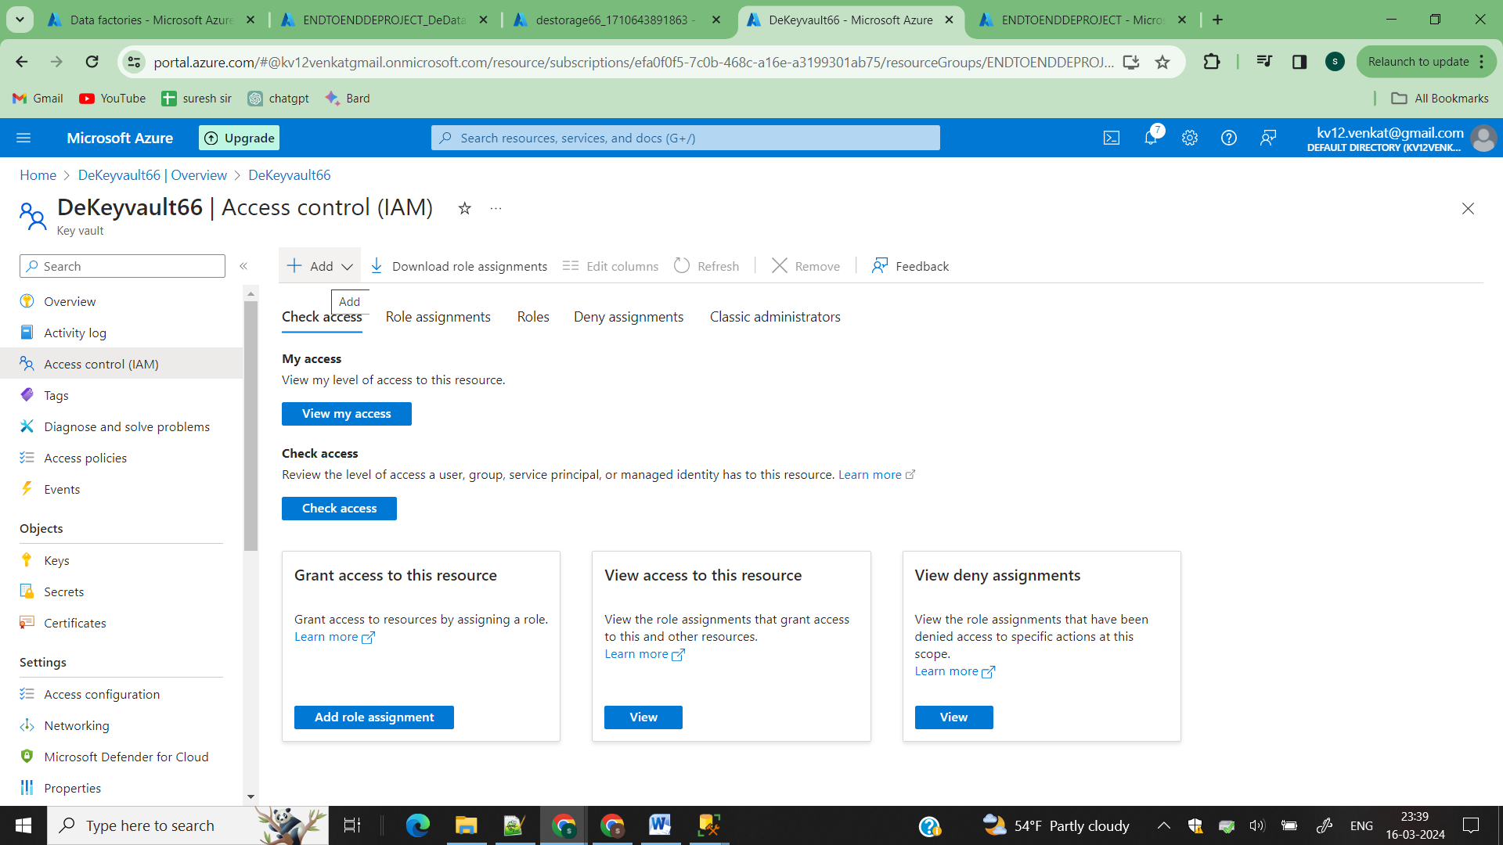

Click on access control and add (add role assignment) and select Key vault administrator

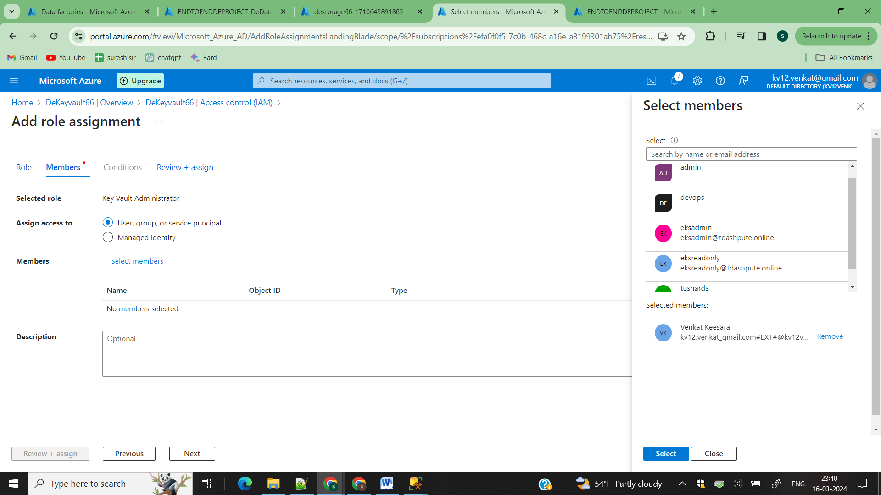

Select your username and click on create so you given keyvault admin access to the selected user now he can create secrets in key vault

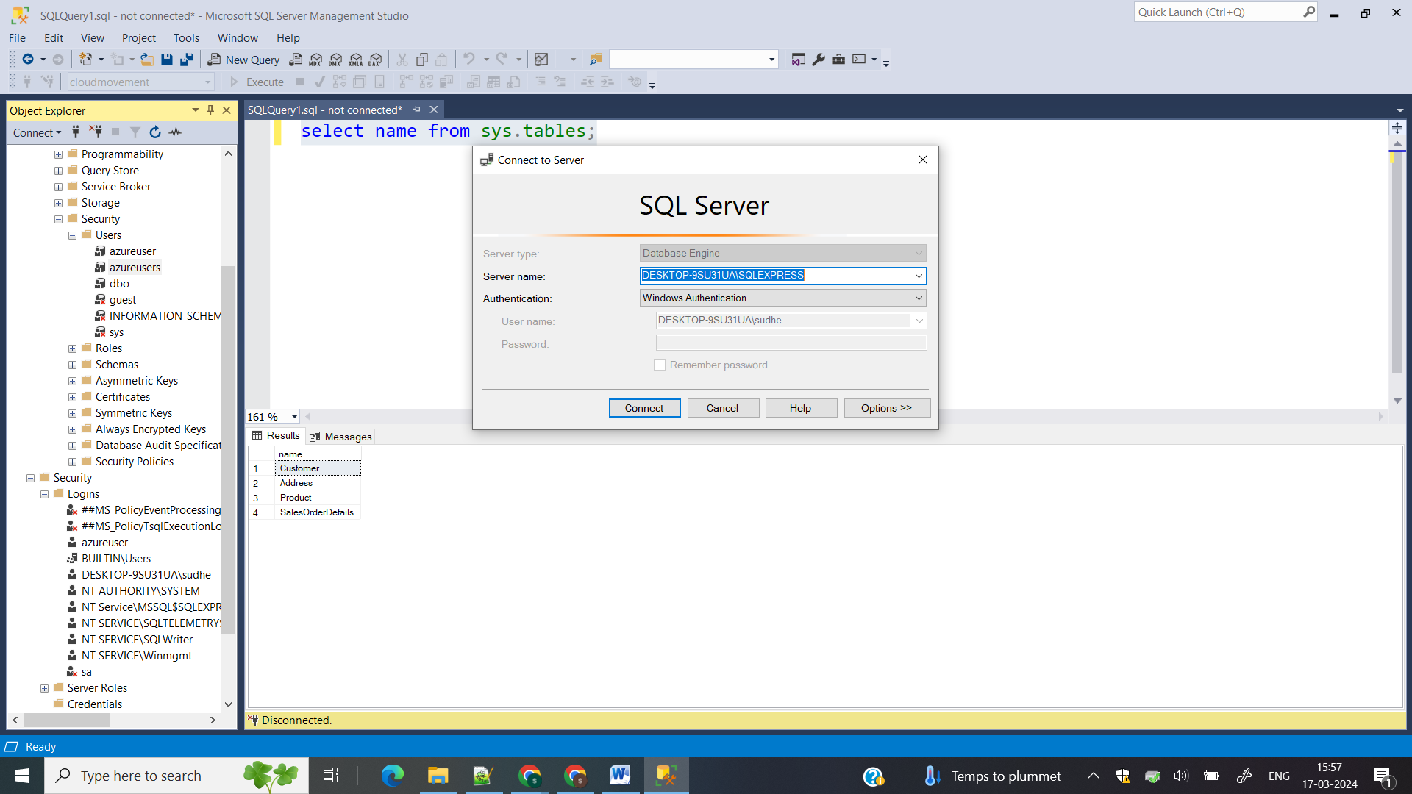

Take the servername and put it in your key vault

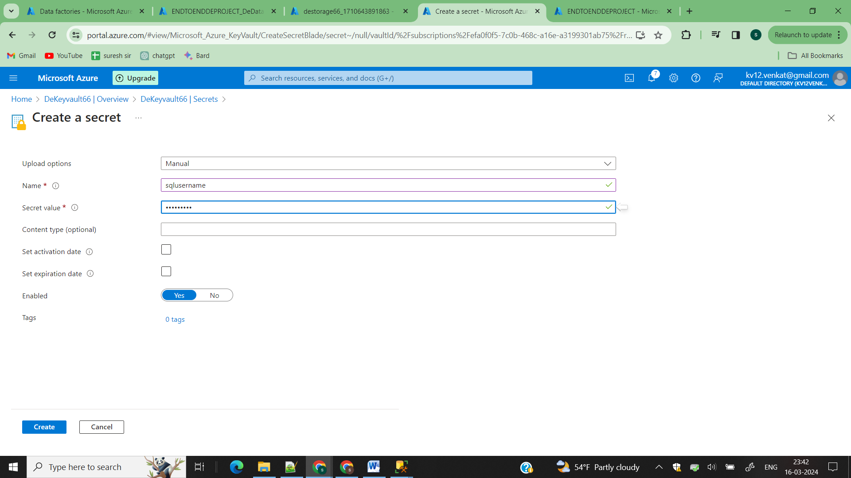

Secrets->click on add->give your name and the username in value field and click on create similarly do it for password also

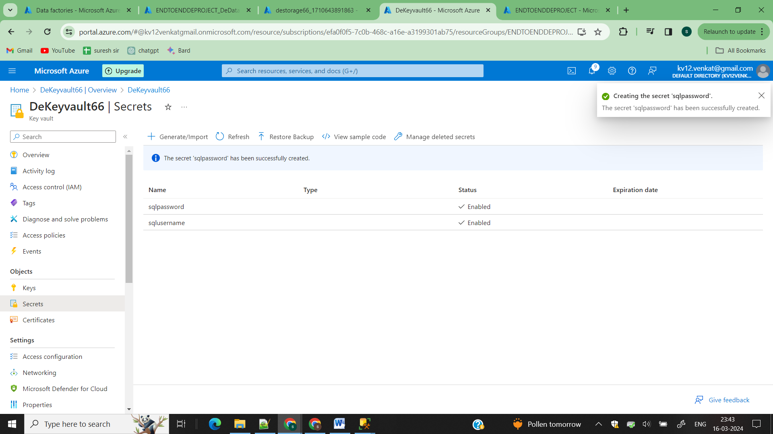

Step2) Data Ingestion part load data from your onpremises sql server to your Azure Data Factory

Since our data is in on premises we need to install selfhosted integration runtime in our local system to move data from onpremise to ADF

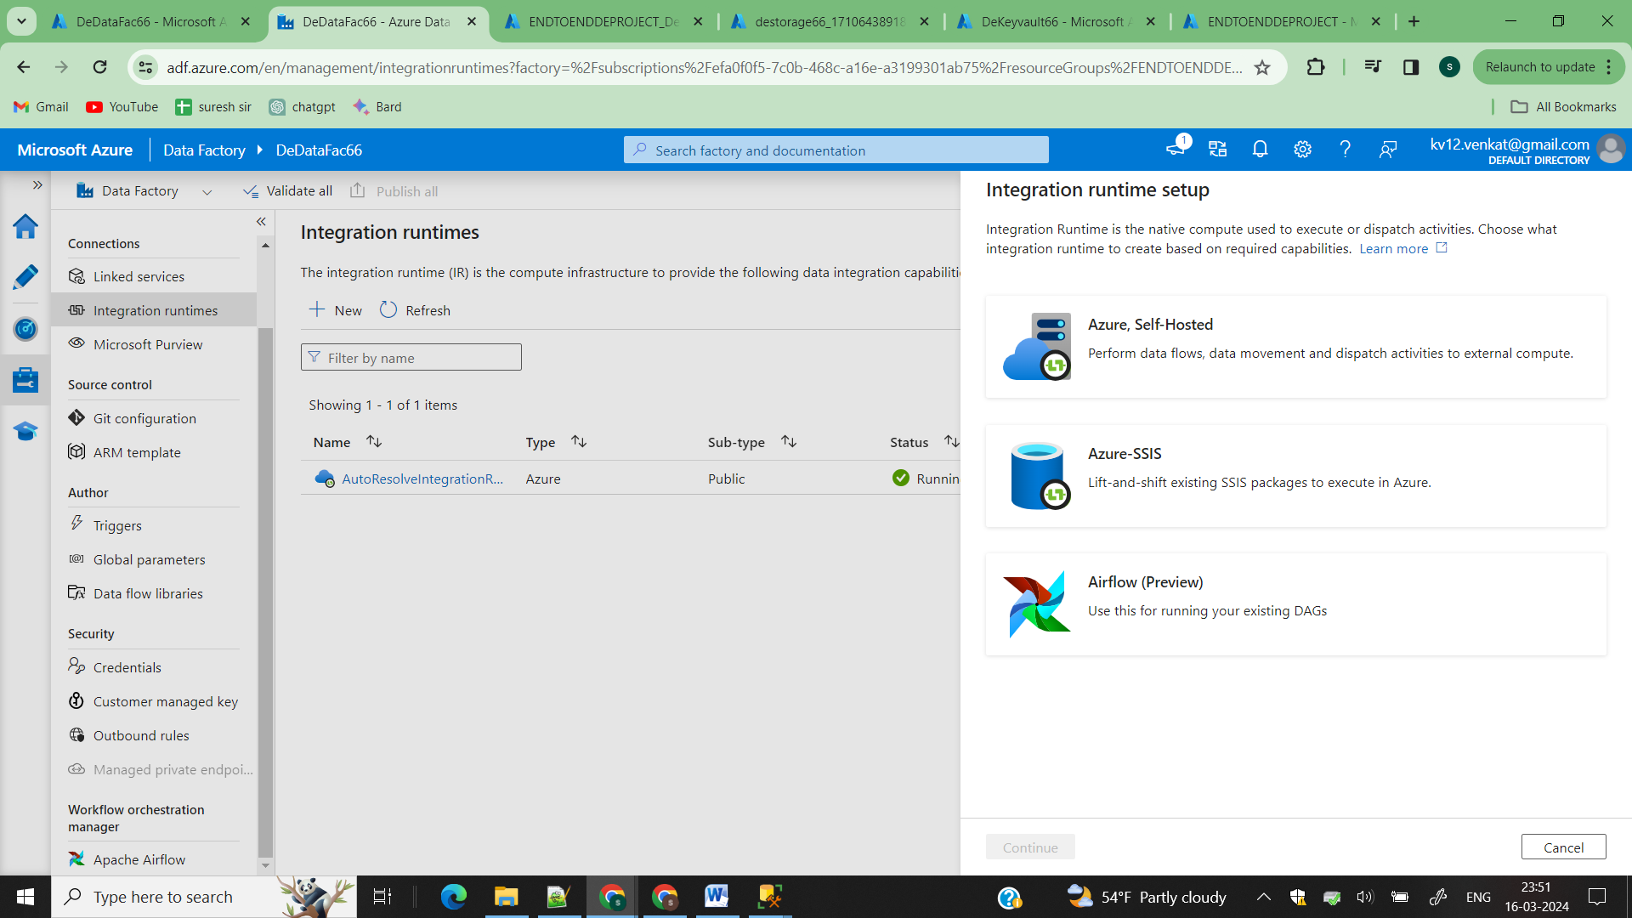

Go to azure datafactory and click on add and select Azure self hosted

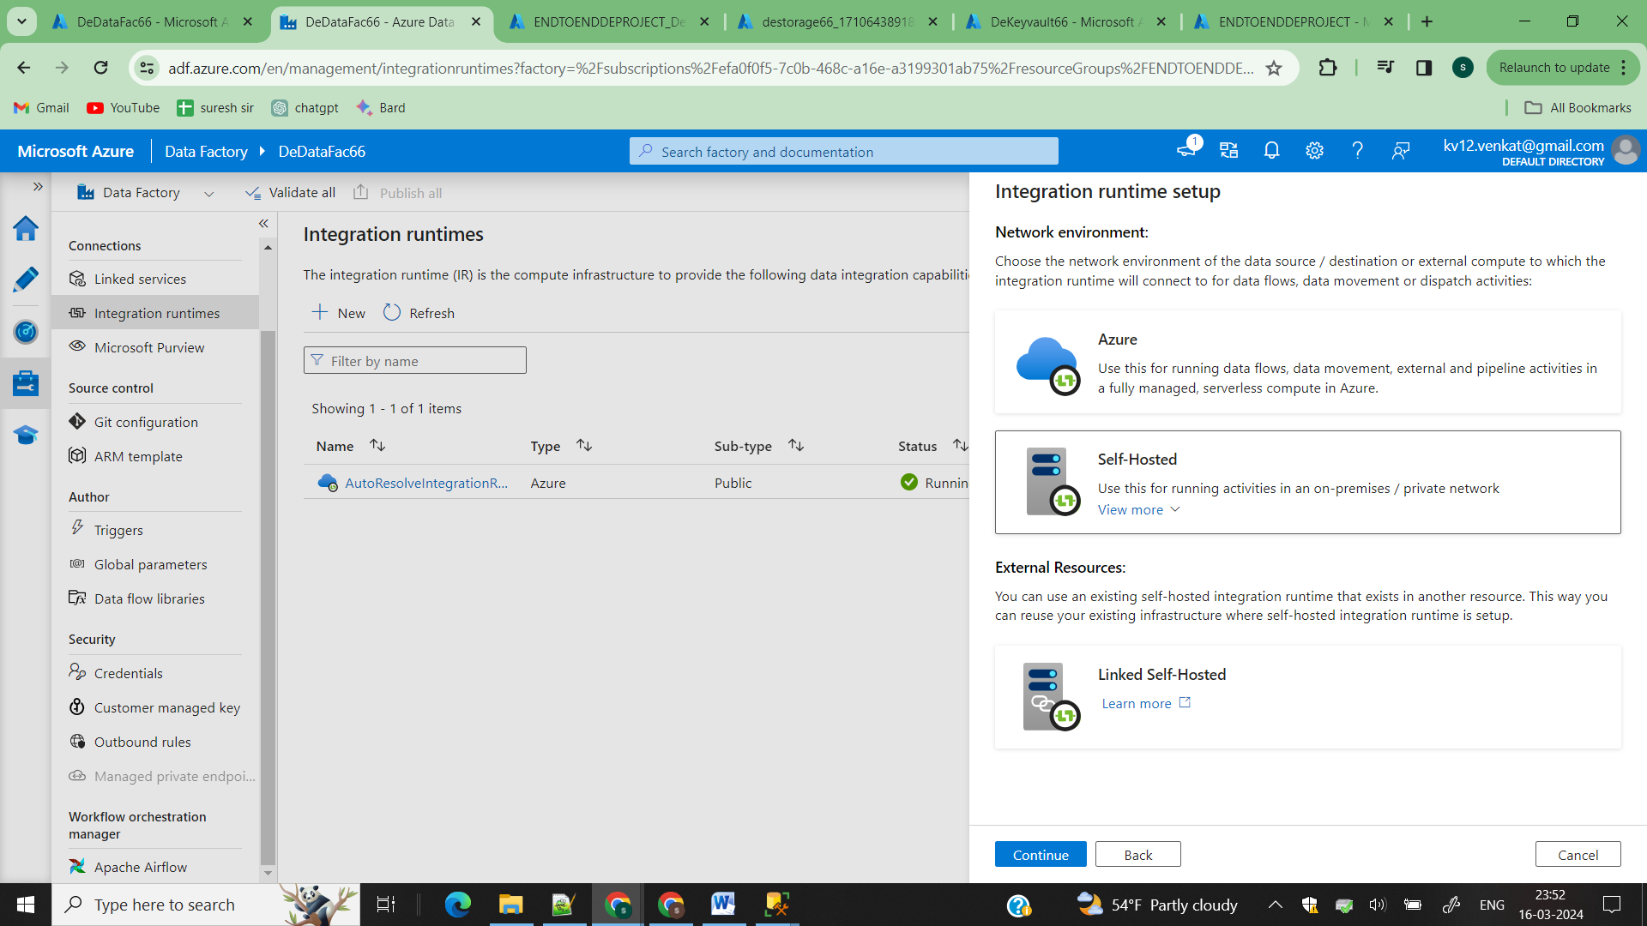

Again click on self hosted

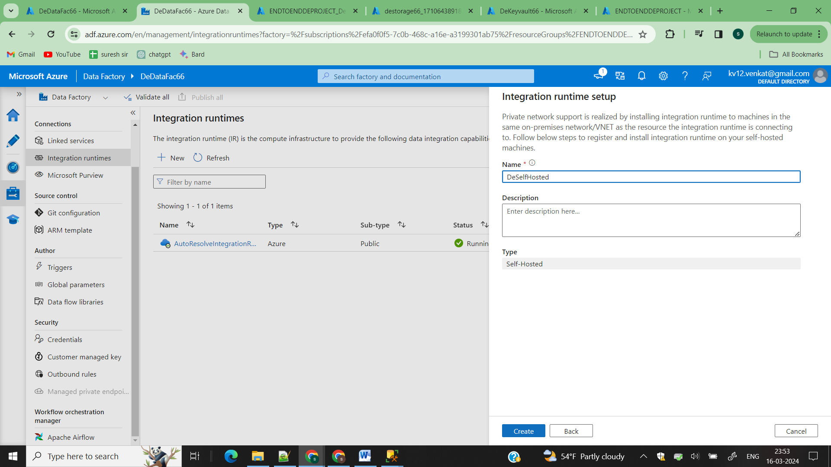

Click on create

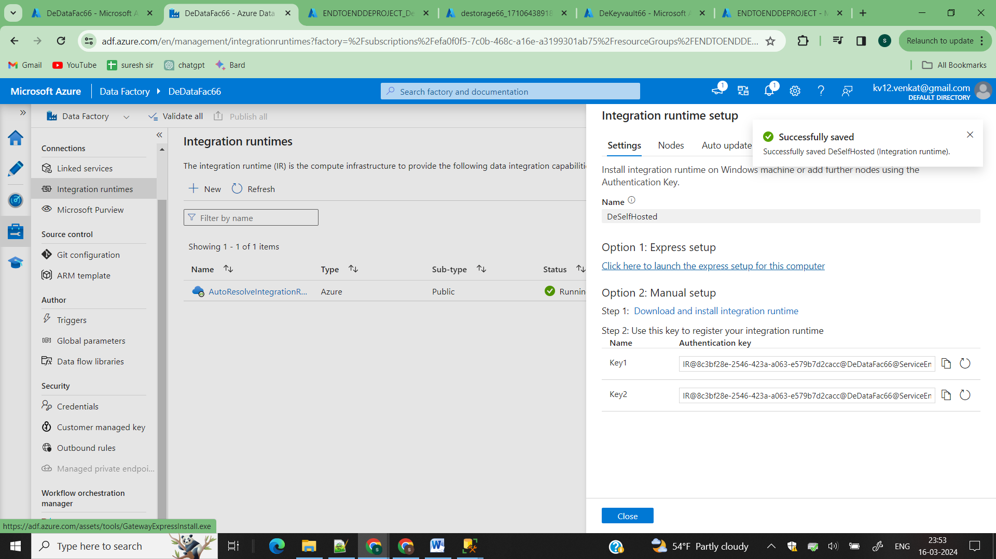

Click on option 1 which will automatically setup IR in your local machine

After installing the Self Hosted IR

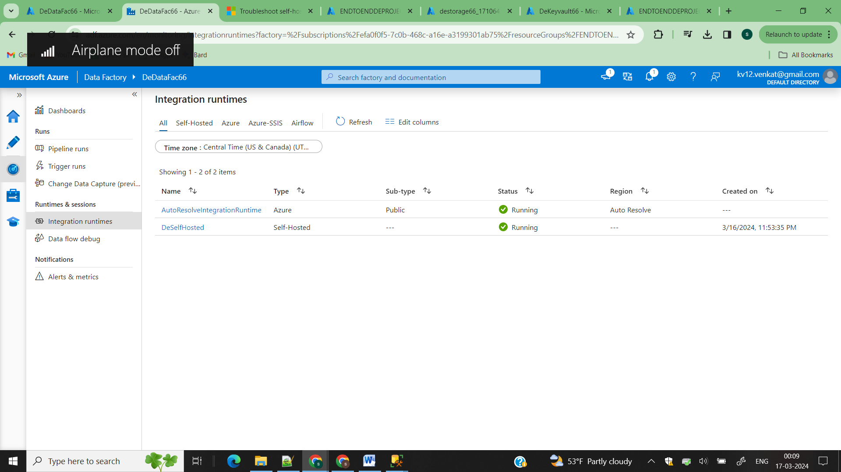

Now we need to create three linked services

1)KeyVault

2)OnpremisesSqlServer

3)ADLS Gen2

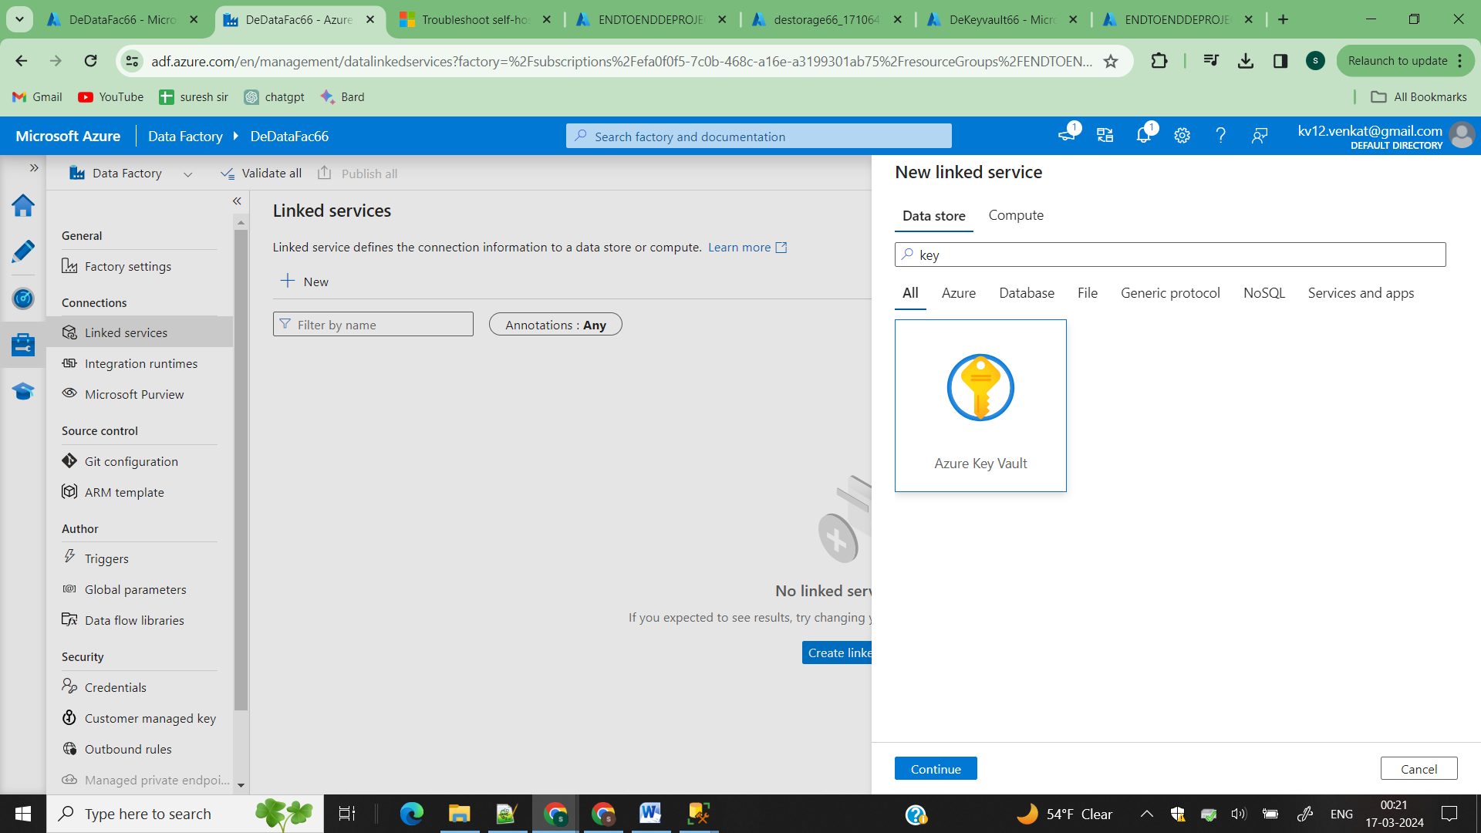

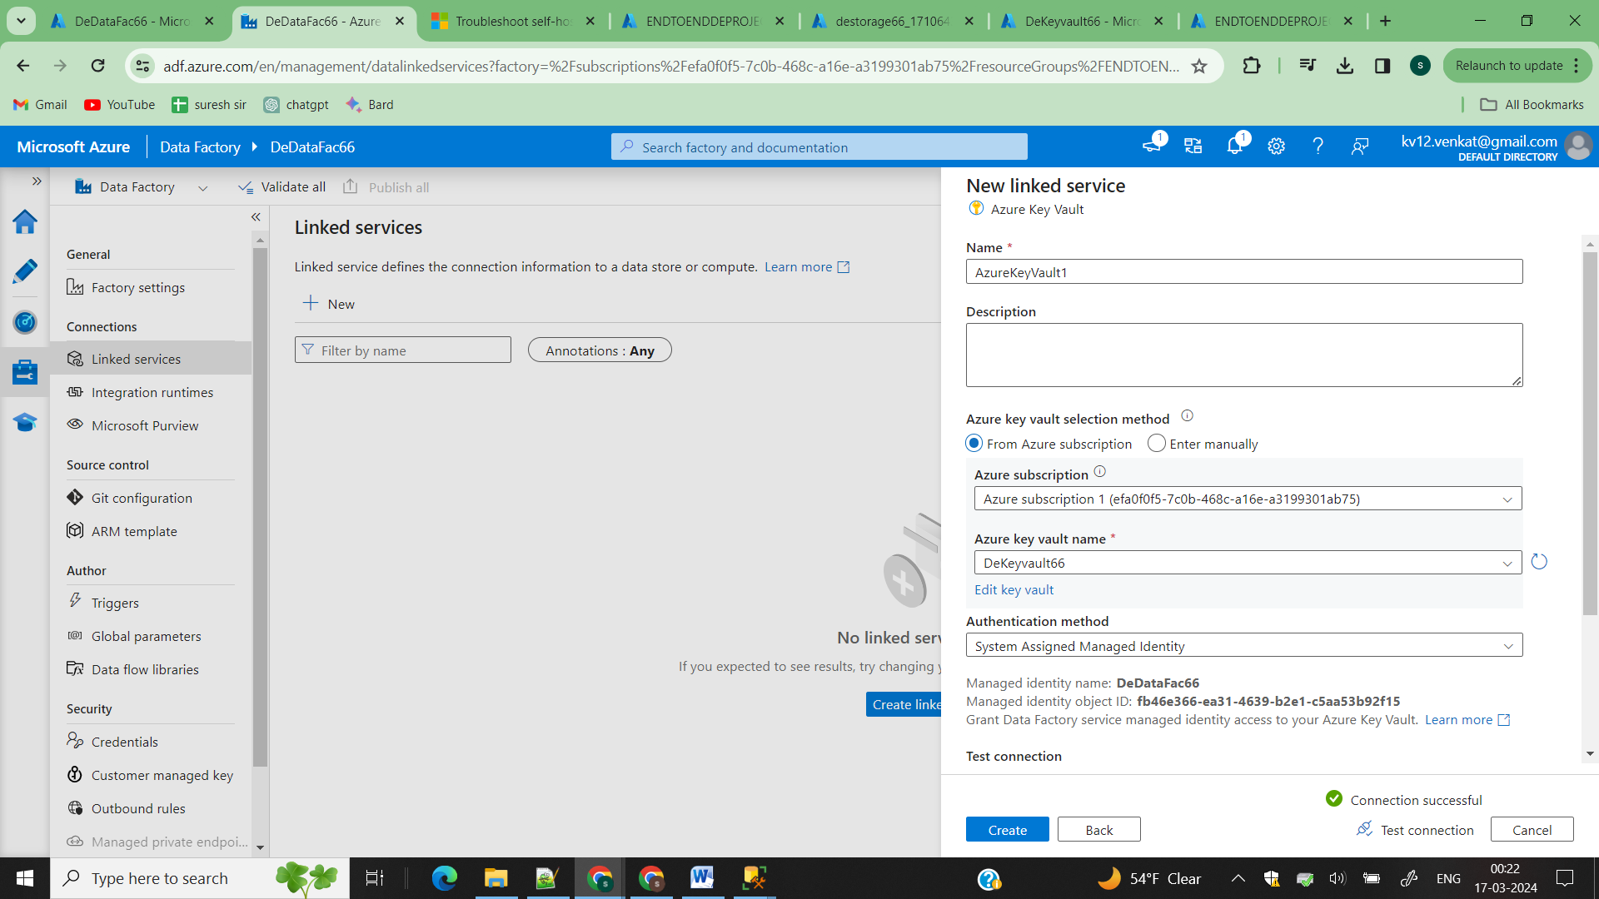

Click on create

To access secrets by ADF you need to give permission to it for that goto Azure Key vault

In previous steps how you given permission to a user in the similar way you have to give the same permission to the datafactory

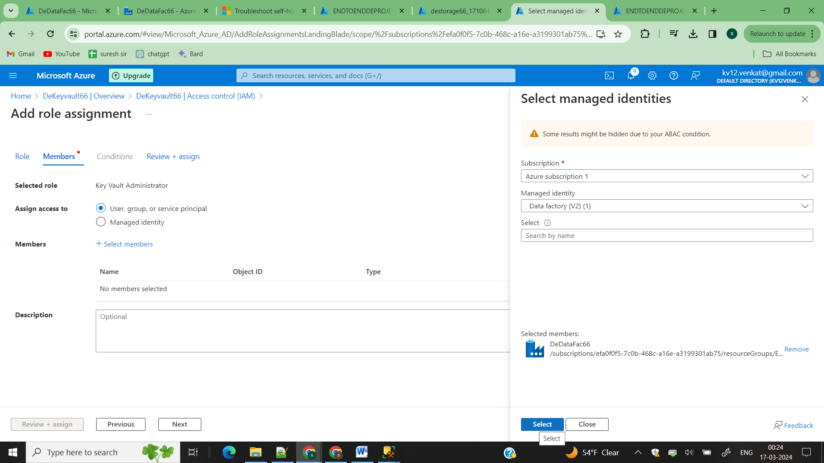

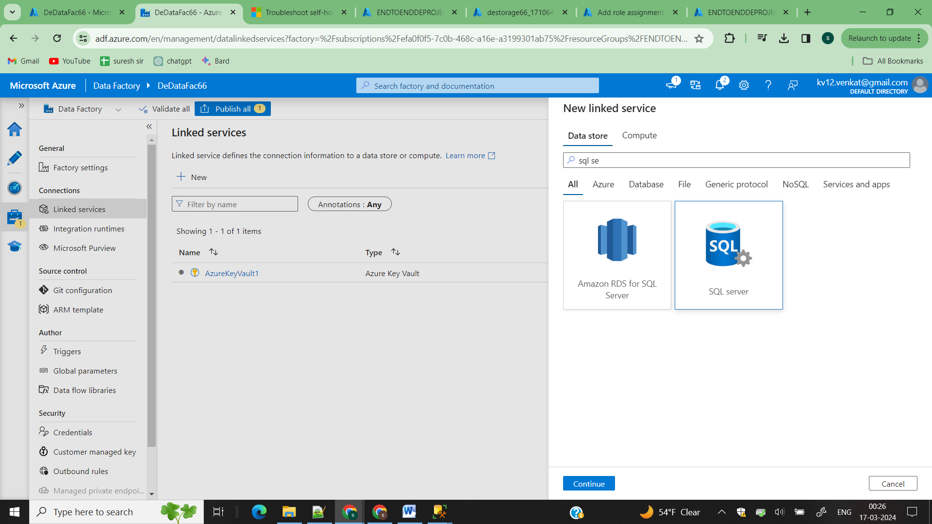

Now create linked service for your sql server

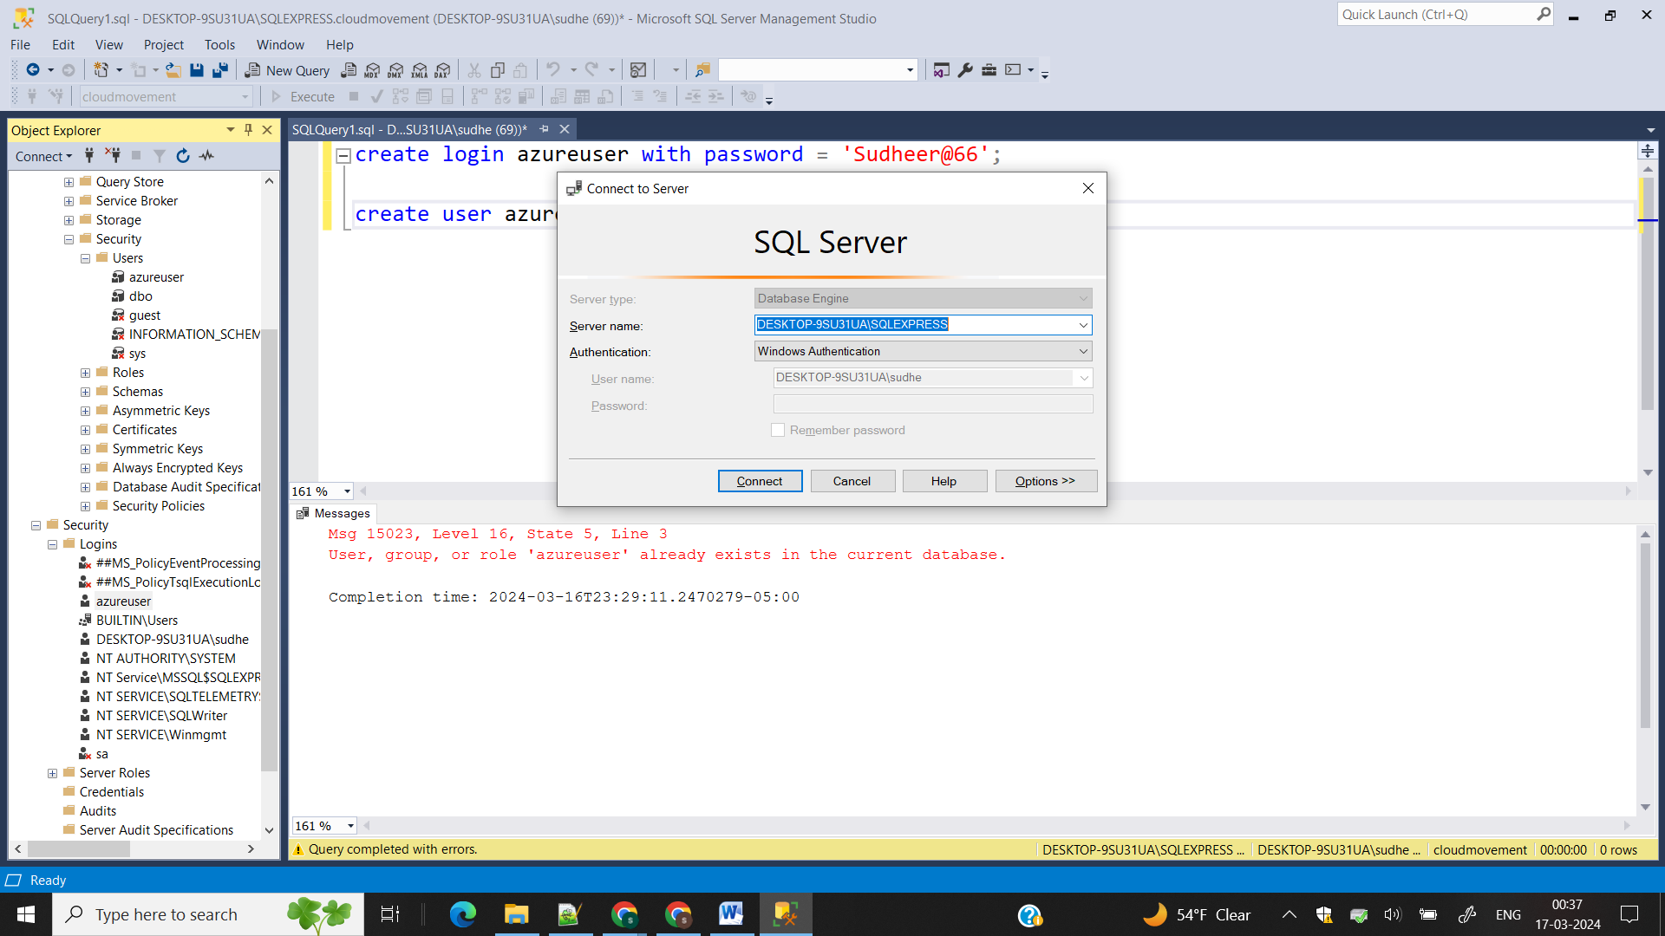

Since my sqlserver is allowing window authentication

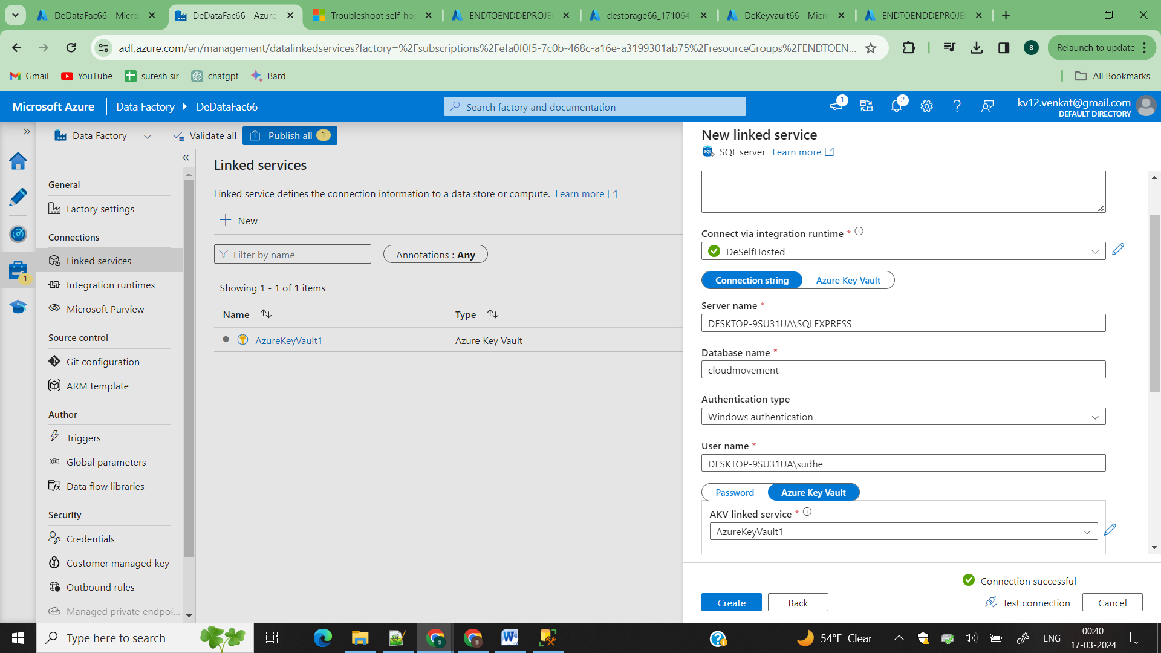

Select window authentication and check connection it works

Goto linked service and click on create and enter the follosing details enter IR has self hosted IR and copy the servername and databse name from it

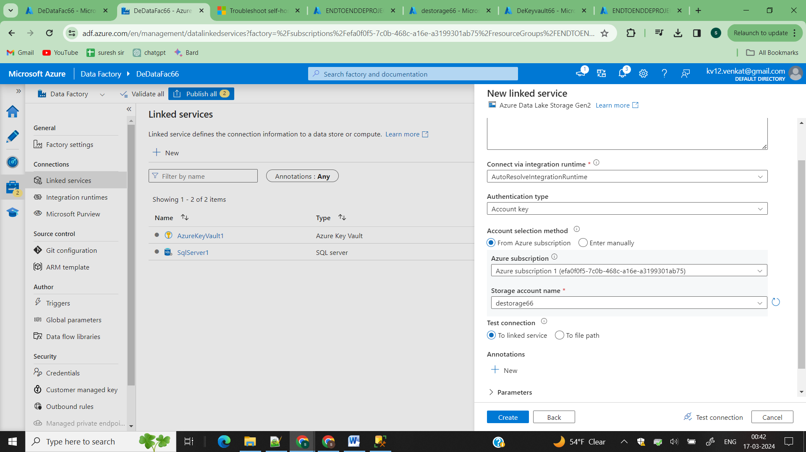

Create linked service for your ADLS 2

Now create dataset for your sqlserver and your ADLS2

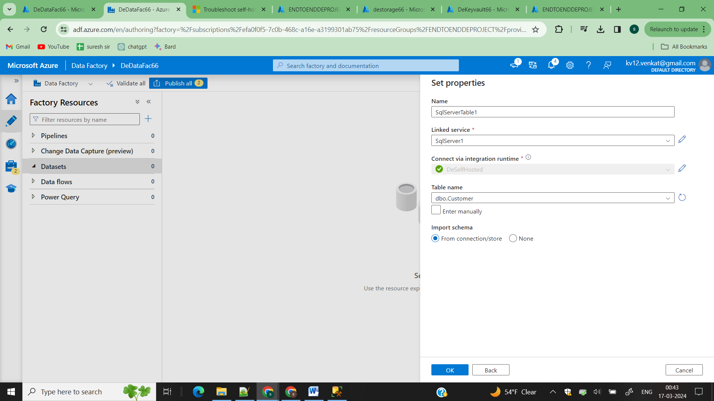

Create data set and give your specified table name

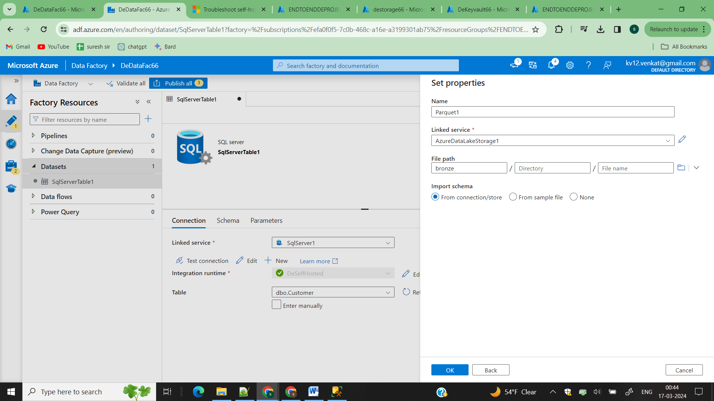

Dataset->parquet->select your linked service->create a bronze container and select it

Step3)

Now create you data pipeline for your data ingestion

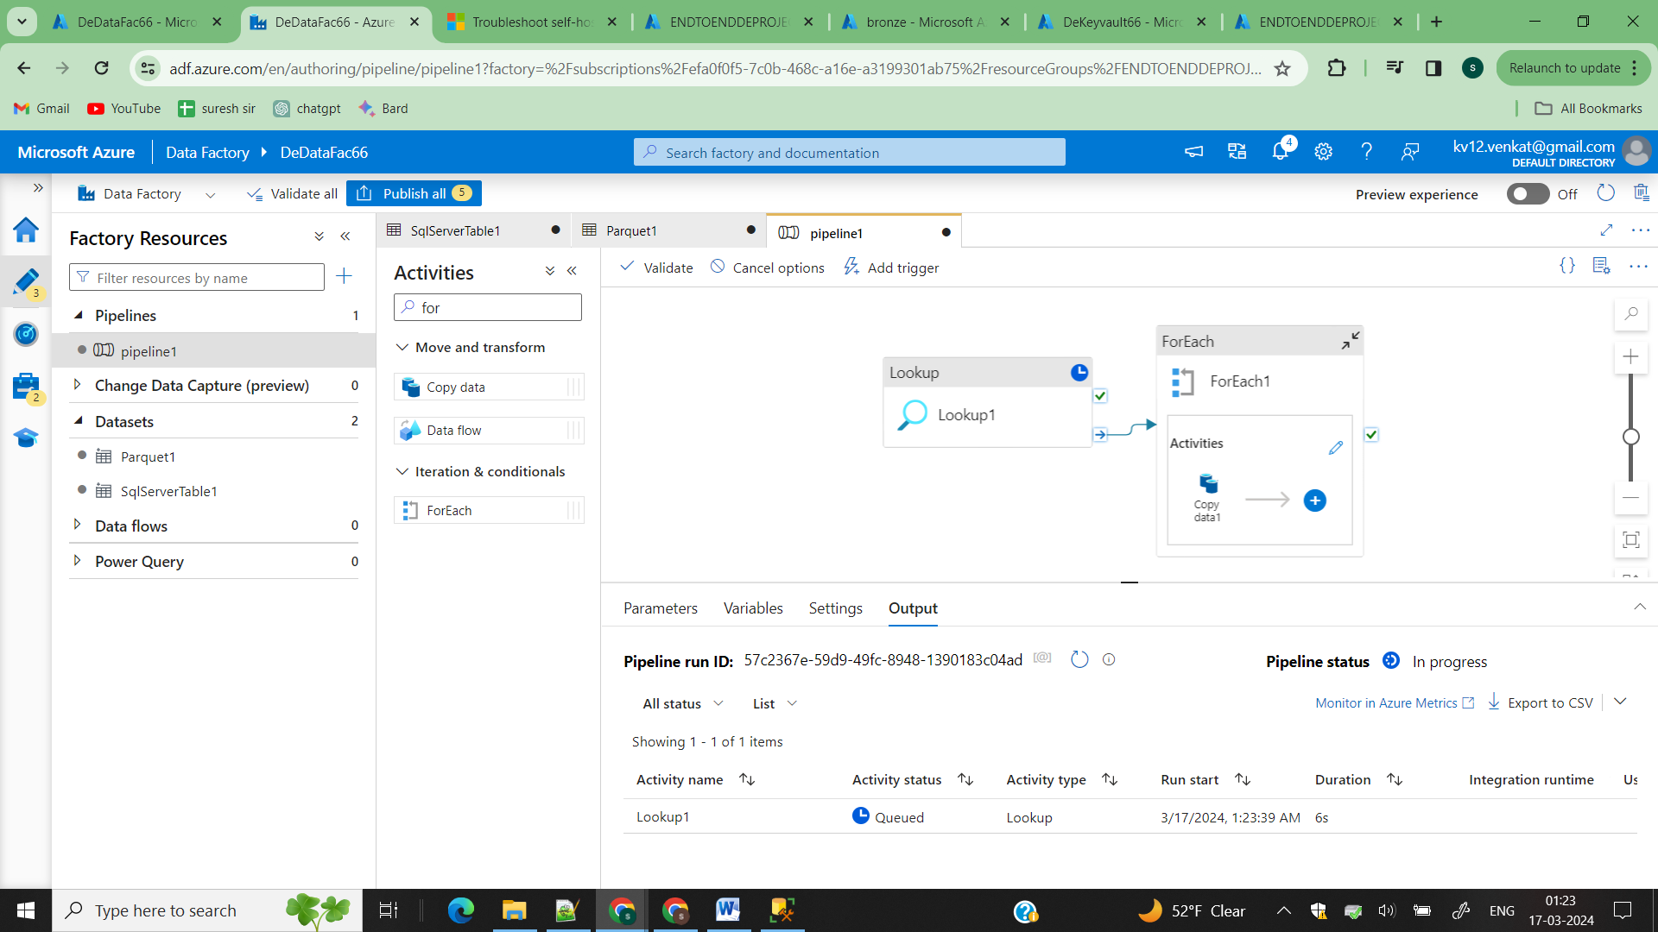

Using lookup activity we get all the tables form sql server

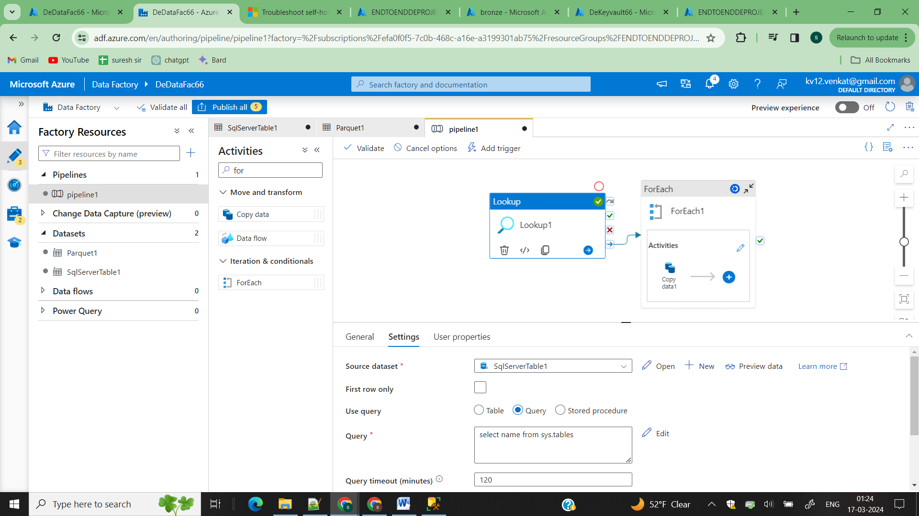

You need (select name from sys.tables) to write this query and run the lookup activity which return you all the table names

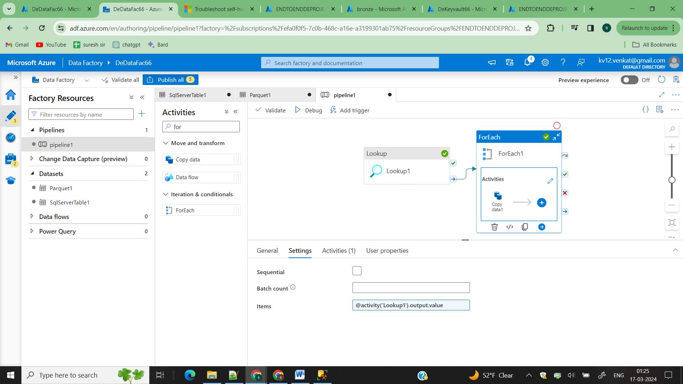

In items of for each **@activity('Lookup1').output.value this will pass all value into a loop one at a time**

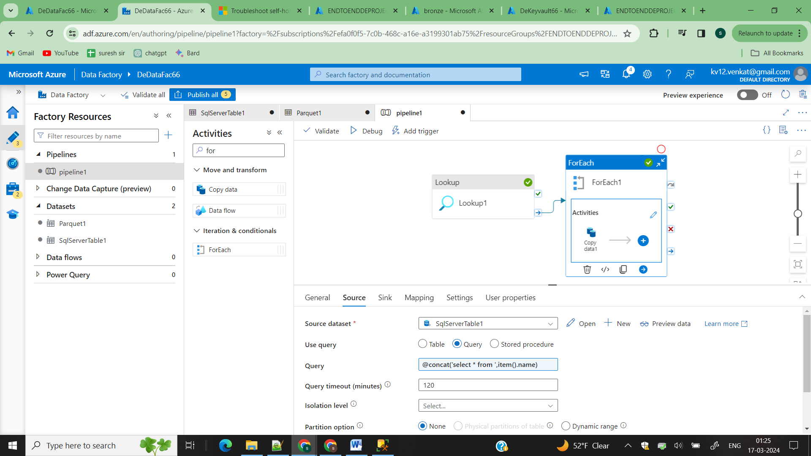

Inside forloop activity we placed copy and in source we are passing the value of each loop and conatinating with the sql query like above **@concat('select * from ',item().name)**

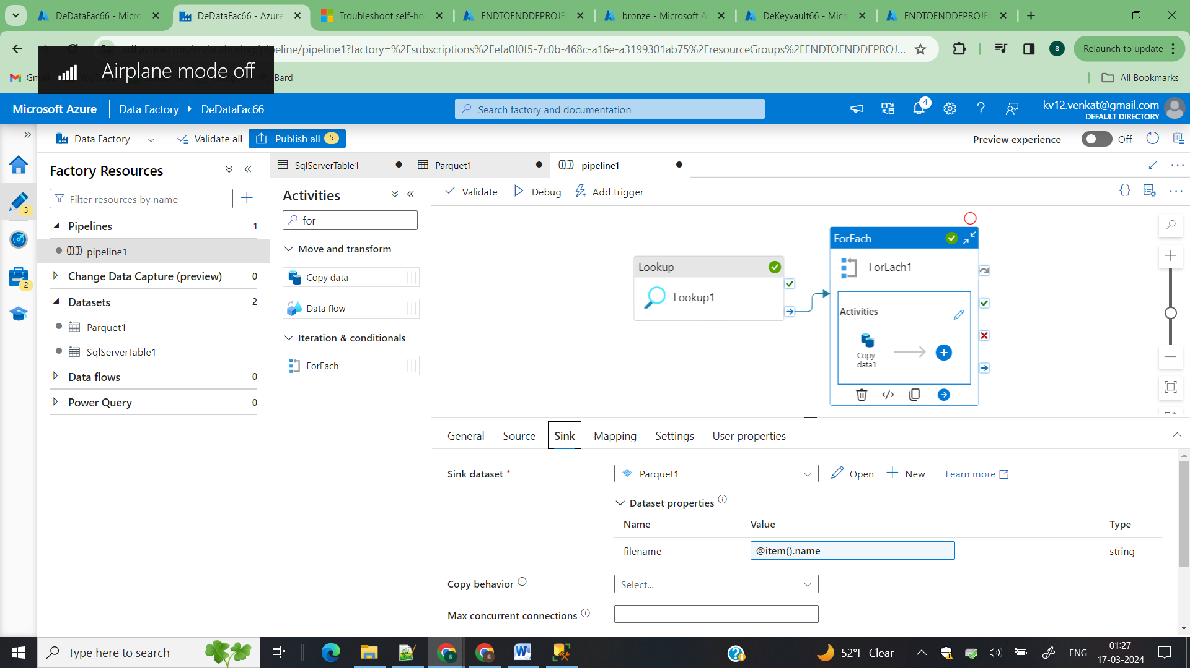

In Sink we need file name to be tablename.parquet for this to happen create a parameter in the dataset and then you can pass values of for loop into that parameter

Then click on debug

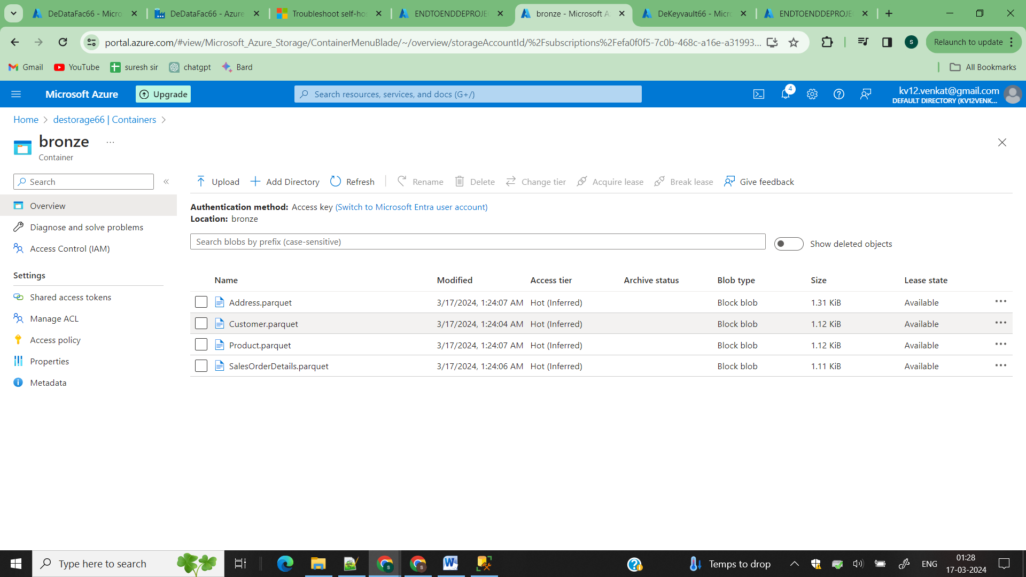

All your table data is loaded into ADLS as parquet format

Step4)

Data Transformation layer

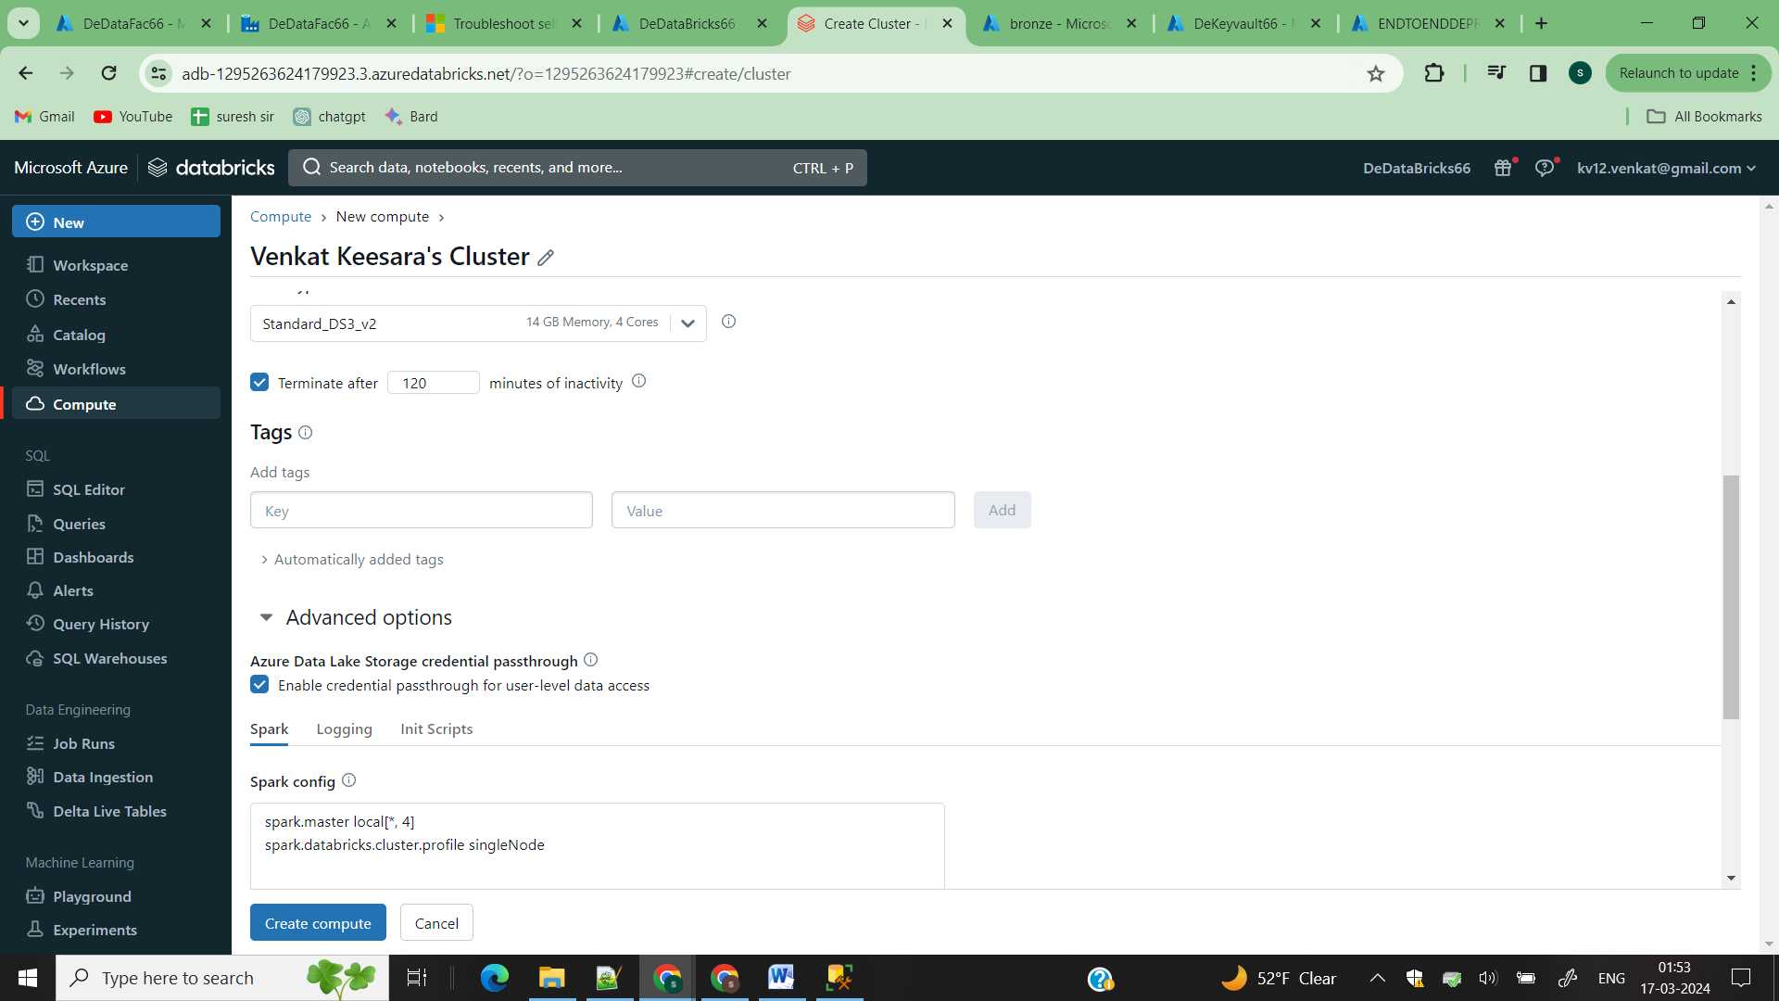

Open your databricks->compute create compute

[Note: In advance check the ADLS Credantial]

So the databricks can access the ADLS Gen2

configs = {"fs.azure.account.auth.type": "CustomAccessToken",

          "fs.azure.account.custom.token.provider.class": spark.conf.get("spark.databricks.passthrough.adls.gen2.tokenProviderClassName")

          }

# Optionally, you can add <directory-name> to the source URI of your mount point.

dbutils.fs.mount(

  source = "abfss://bronze@destorage66.dfs.core.windows.net/",

  mount_point = "/mnt/bronze",

  extra_configs = configs)

dbutils.fs.mount(

  source = "abfss://silver@destorage66.dfs.core.windows.net/",

  mount_point = "/mnt/silver",

  extra_configs = configs)

dbutils.fs.mount(

  source = "abfss://gold@destorage66.dfs.core.windows.net/",

  mount_point = "/mnt/golde",

  extra_configs = configs)

Create a note book and place this code and update mount points with your container names and adls names

files = dbutils.fs.ls('mnt/bronze')

for eachFile in files:

    filePath = eachFile.path

    df = spark.read.format("parquet").load(filePath)

    df.write.format("delta").mode("overwrite").save(f"/mnt/silver/{eachFile.name}/")

Create a notebook that performs transformations in from bronze to silver and attach this notebook in your pipeline

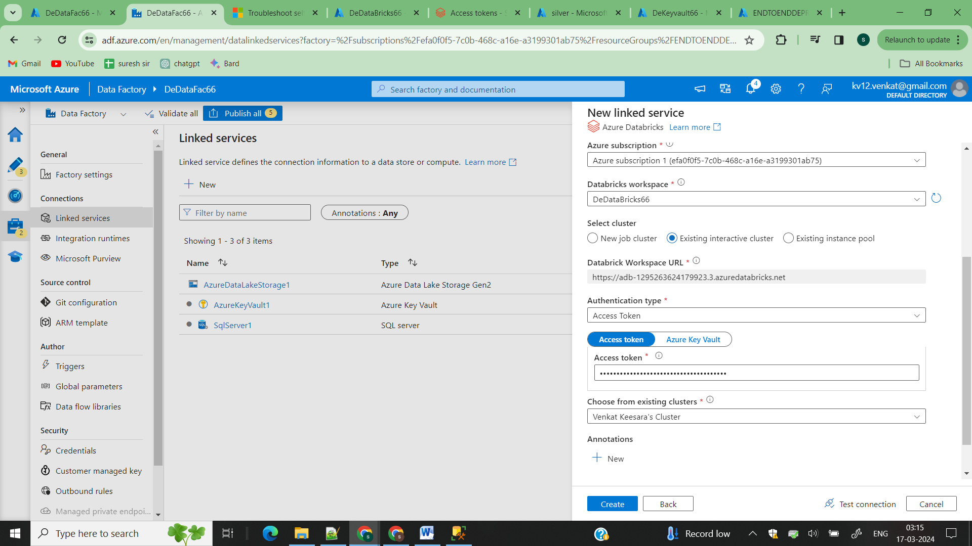

Now create a linked service

Create->compute->Azure Data Bricks -> configure with the given detail

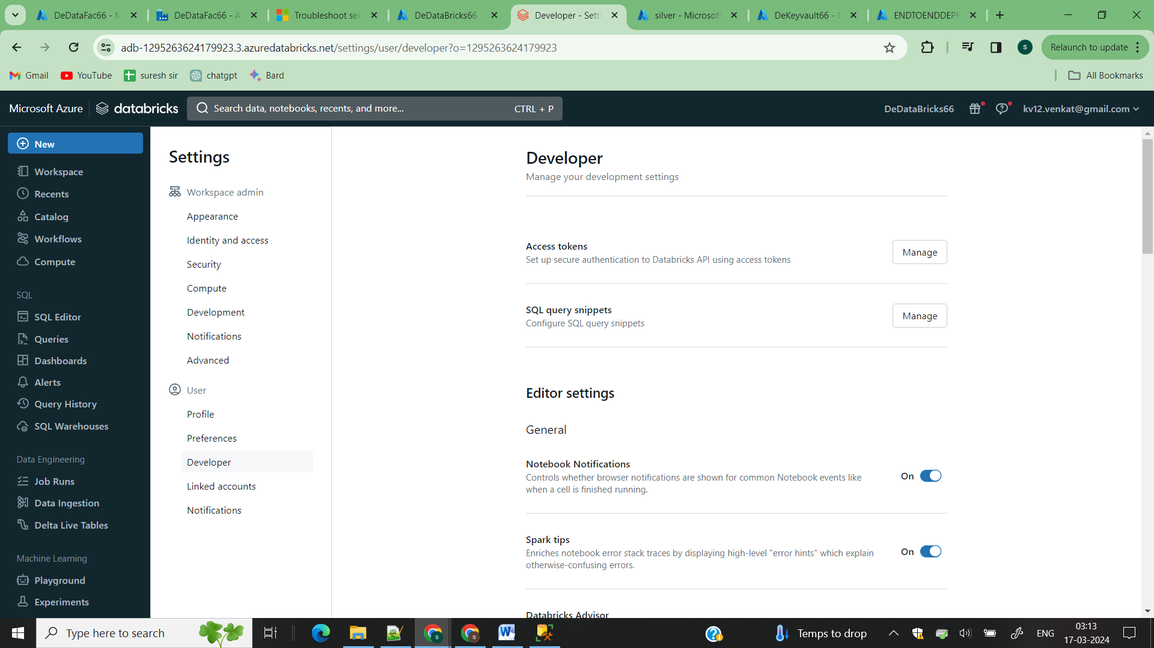

In Databricks user->usersettings->developer-> there you create your tokens and place itin linked service to connect to databricks

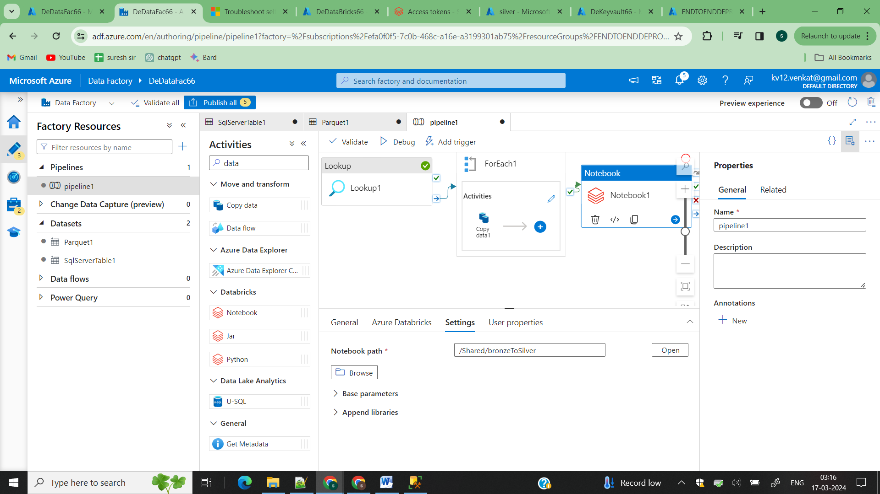

Then attach your notebook activity and browse your notebook and trigger the pipeline

Step5)

Loading data into synapse analytics

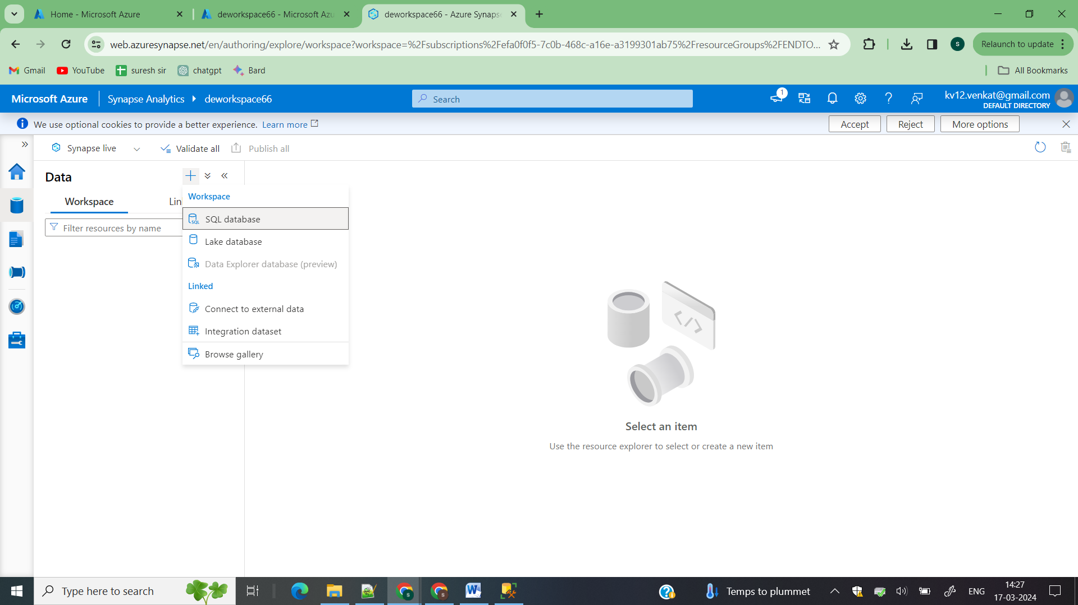

Open your synapse workspace and create a serverless sql database

Serverless sql database is a compute power to perform operations on our ADLS2

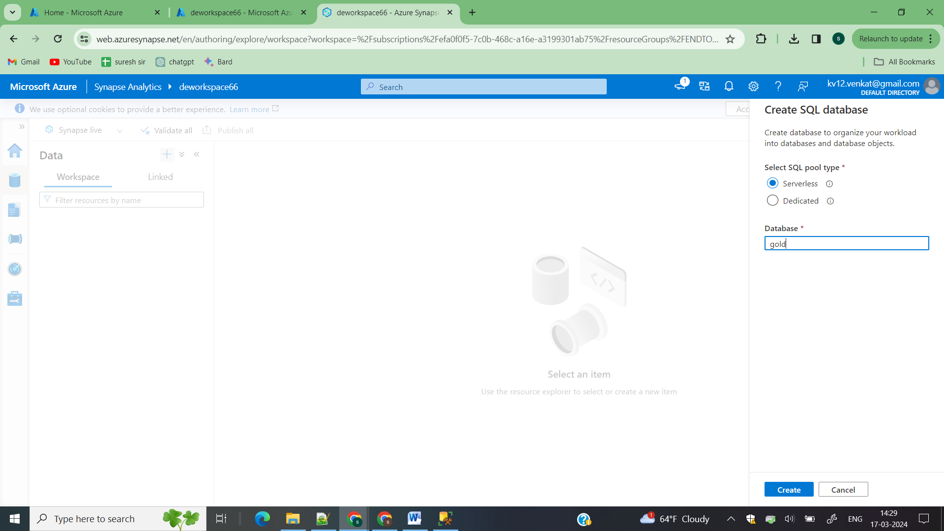

Click on create

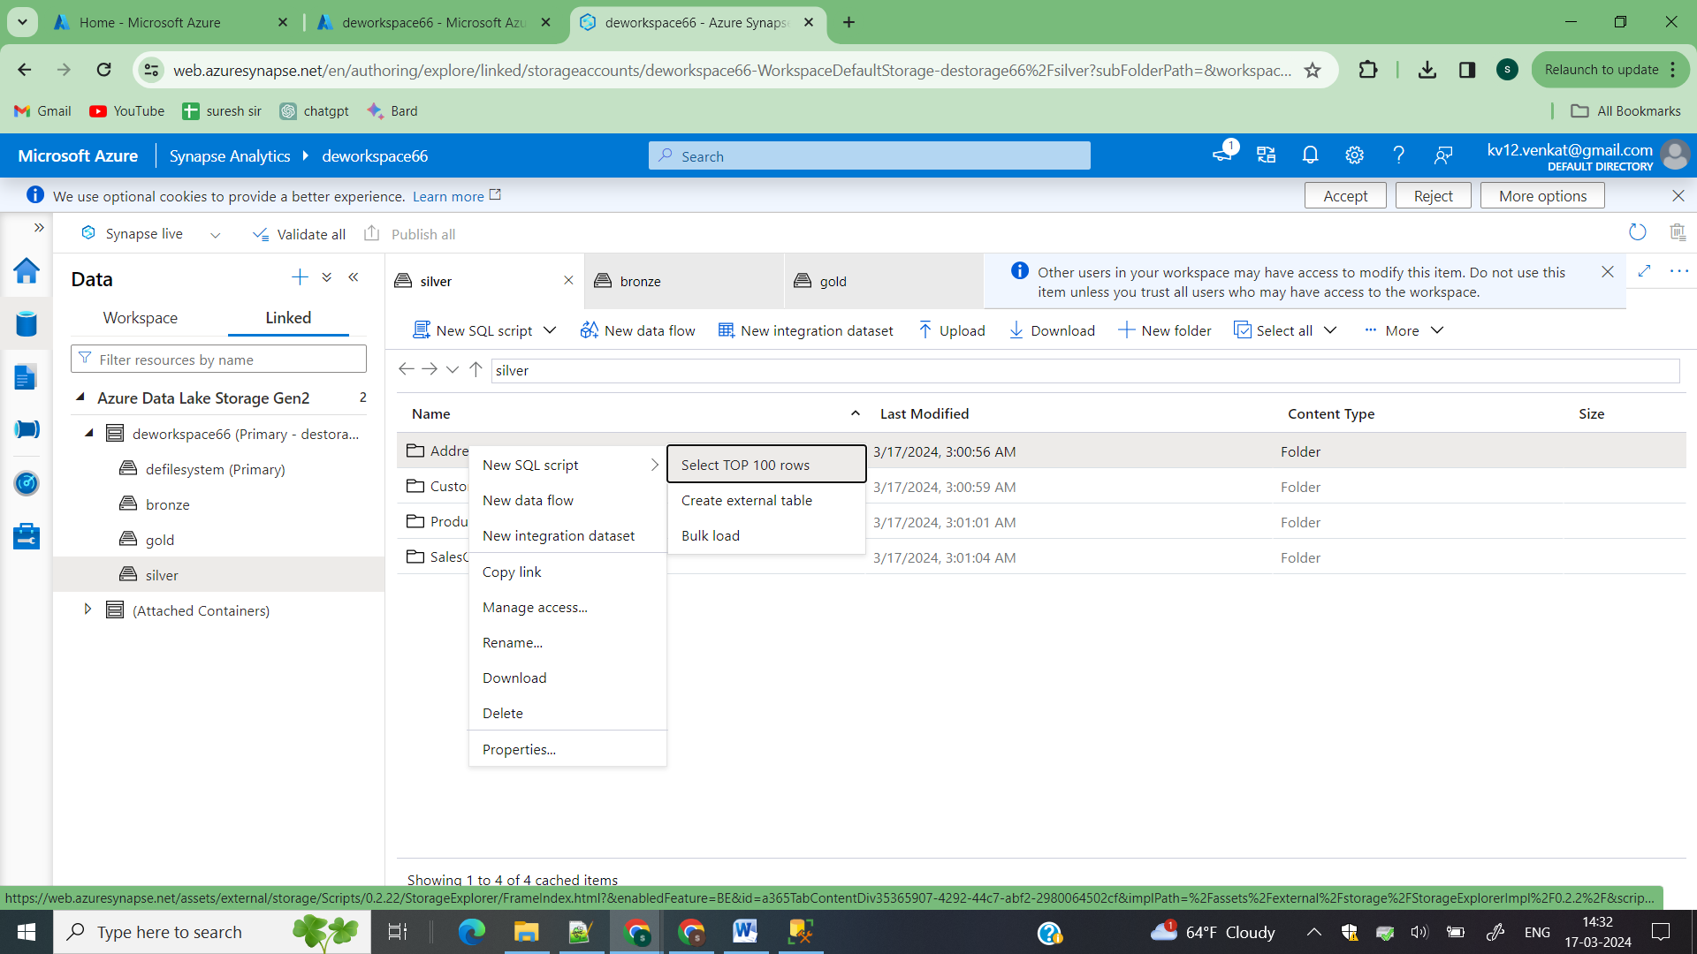

Now you database is created on top of your ADLS2

Linked->select your ADLS2->go to your file and right click on file there you can see sql script click on top 100 which automatically create a sample script using t-sql

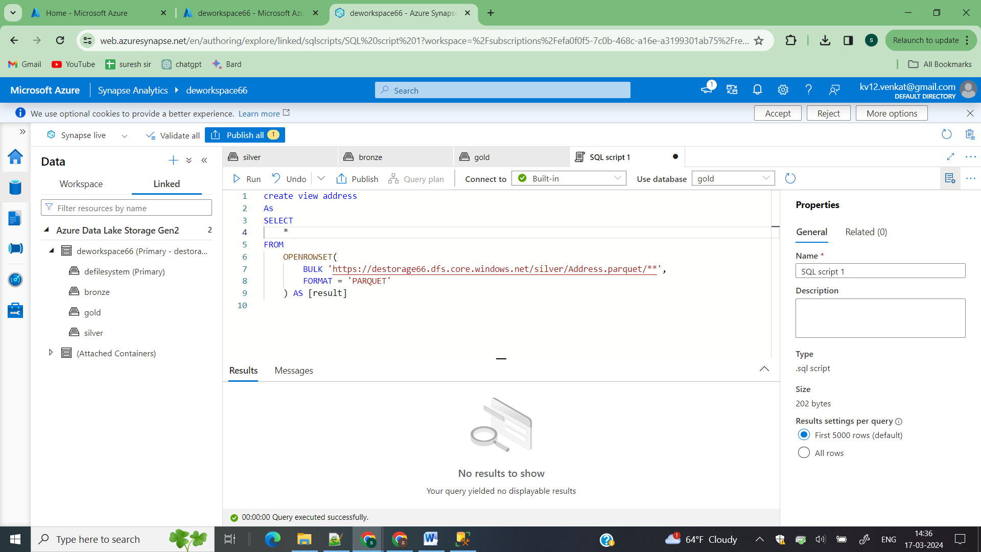

Now in script create a view in your database on top select your database and create a view a shown and run then the view gets created in your database [gold]

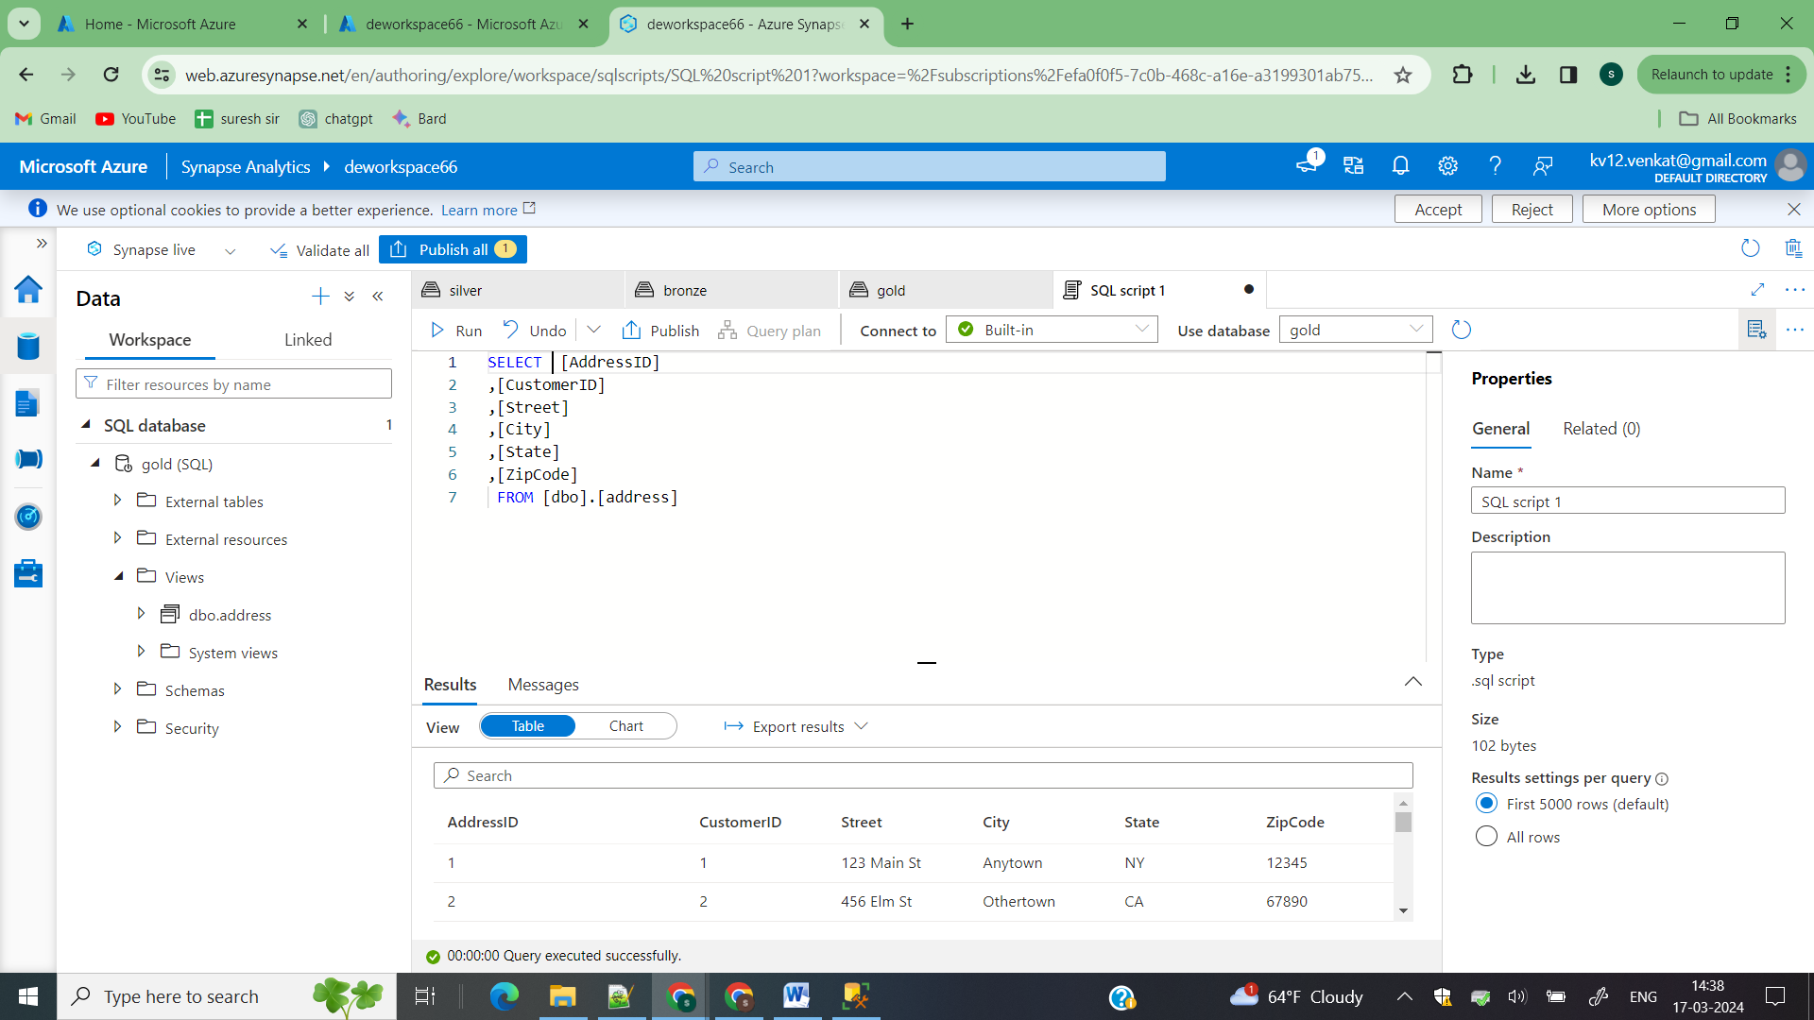

Now using that view you can fetch data from ADLS2 directly

Instead of creating the view for each table manually lets create stored procedure and use the in synapsepipeline to create our views automatically

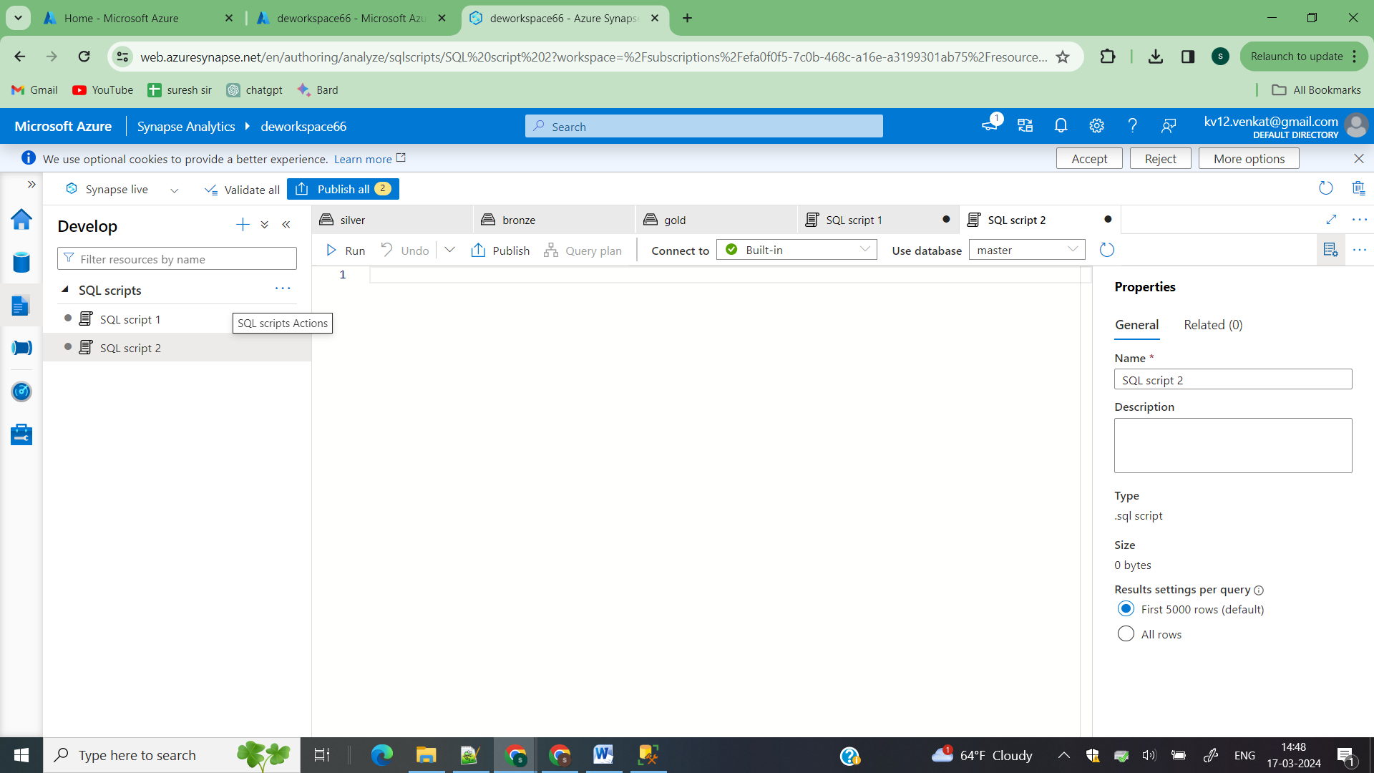

To do that go to develop->sql scripts

USE gold;

GO

CREATE OR ALTER PROCEDURE viewInGoldProc

    @viewName NVARCHAR(100),

    @fileName NVARCHAR(100)

AS

BEGIN

    DECLARE @statement NVARCHAR(MAX);

    SET @statement = N'CREATE OR ALTER VIEW ' + QUOTENAME(@viewName) + N' AS

    SELECT *

    FROM OPENROWSET(

        BULK ''https://destorage66.dfs.core.windows.net/silver/' + @fileName + N'/**'',

        FORMAT = ''PARQUET''

    ) AS [result];';

    EXEC sp_executesql @statement;

END;

Run this procedure in your gold database

Now lets create a synapse pipeline that creates view for every table in your ADLSGen2

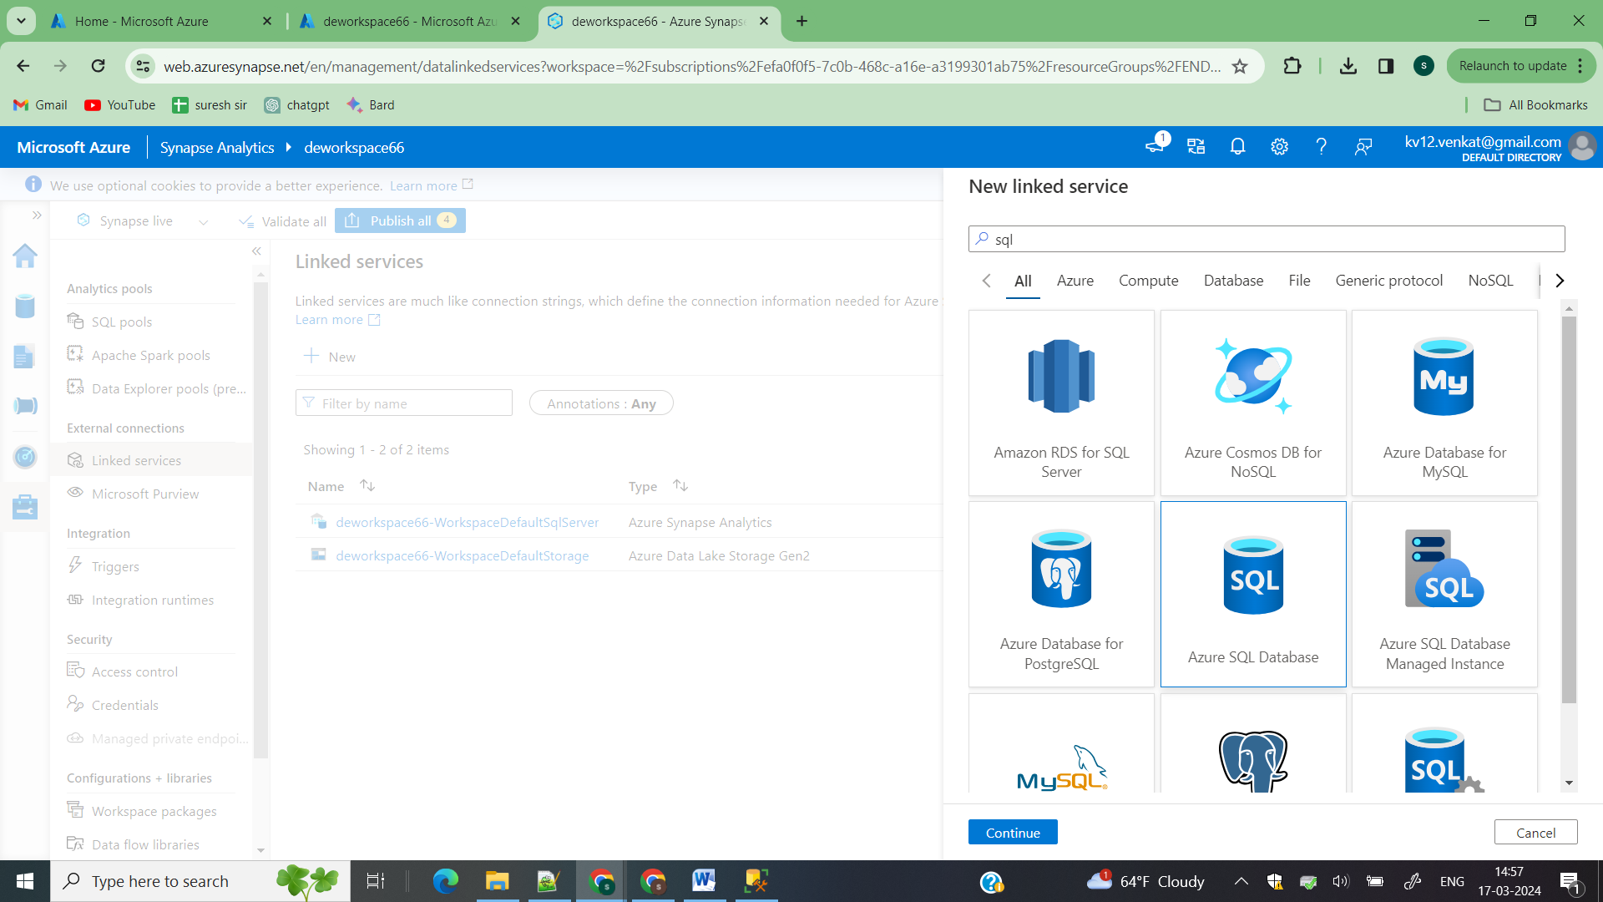

Go to manage->linked service

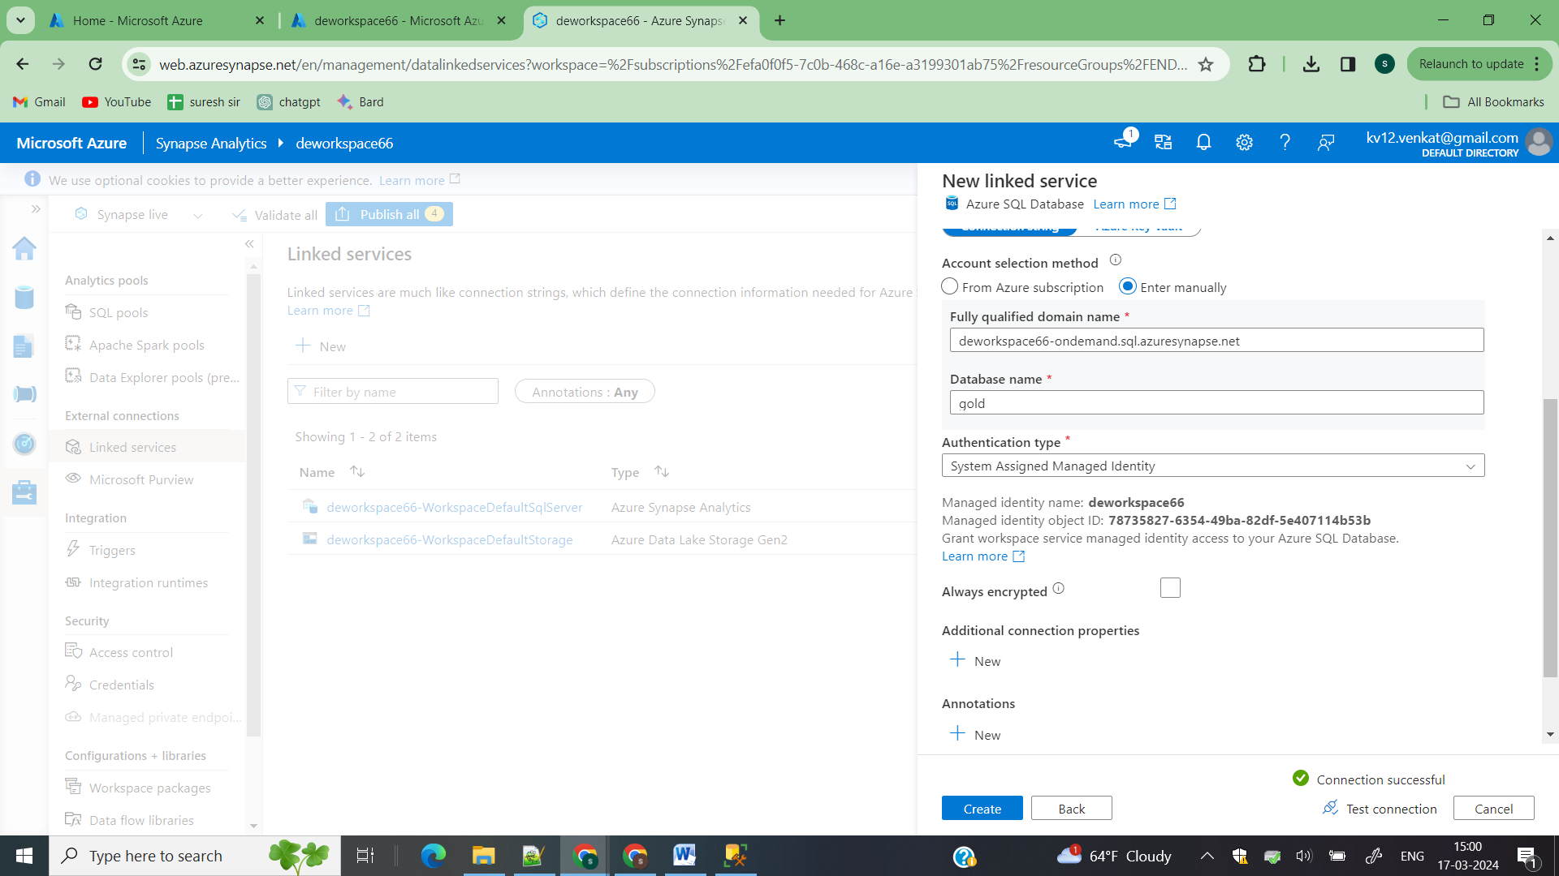

Select accunt select method has manuall

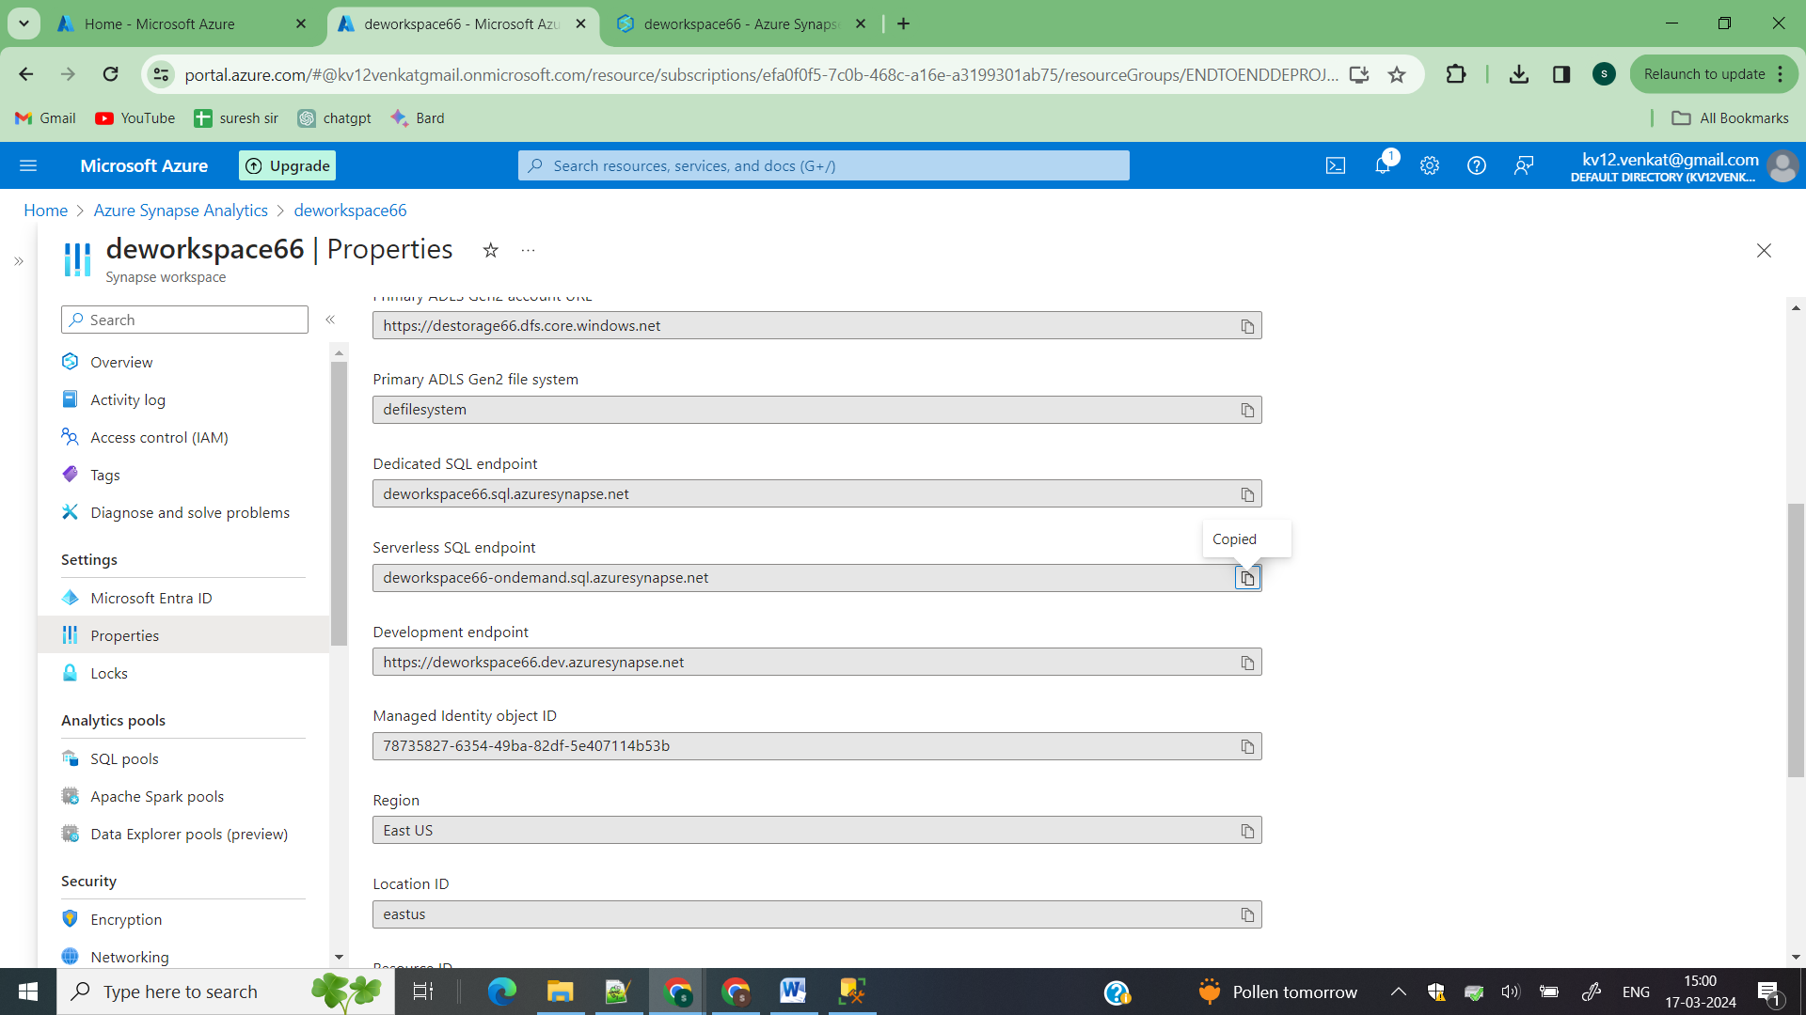

Open your main synapse->properties->serverless sql endpoint

Copy this and paste in your linked service and enter your database name and click on check connection

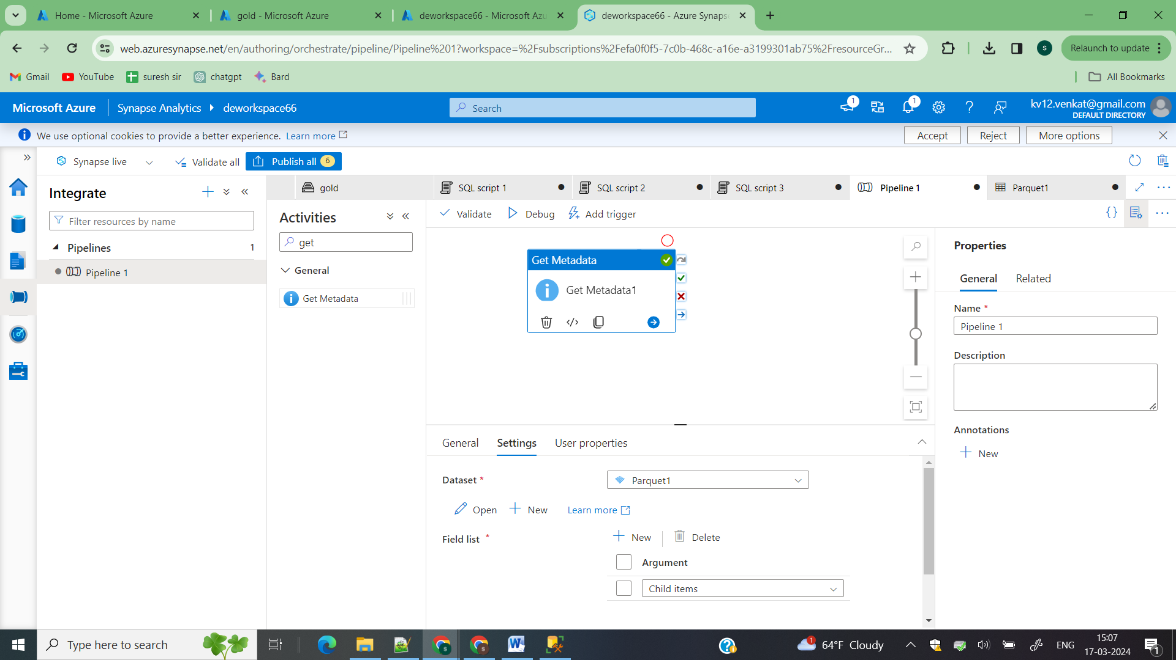

Go to integrate->pipeline create it

Create dataset of adls2 and select field list has child items

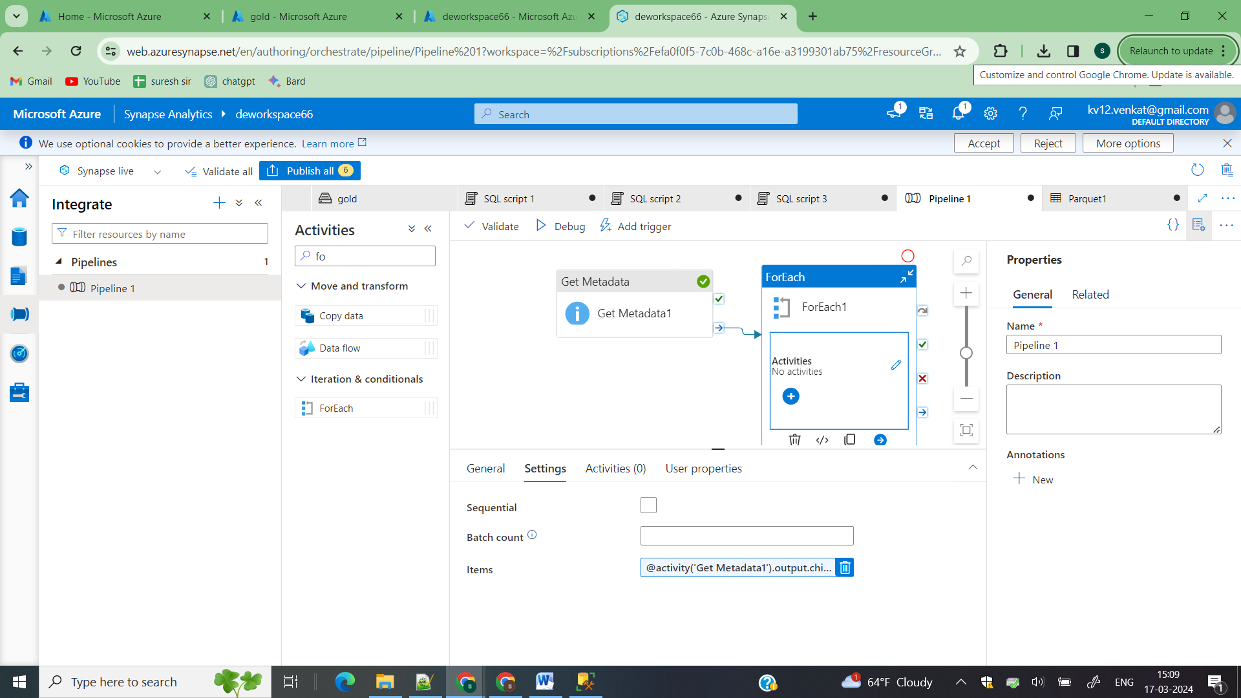

In for each activity get the childnames

@activity('Get Metadata1').output.childItems

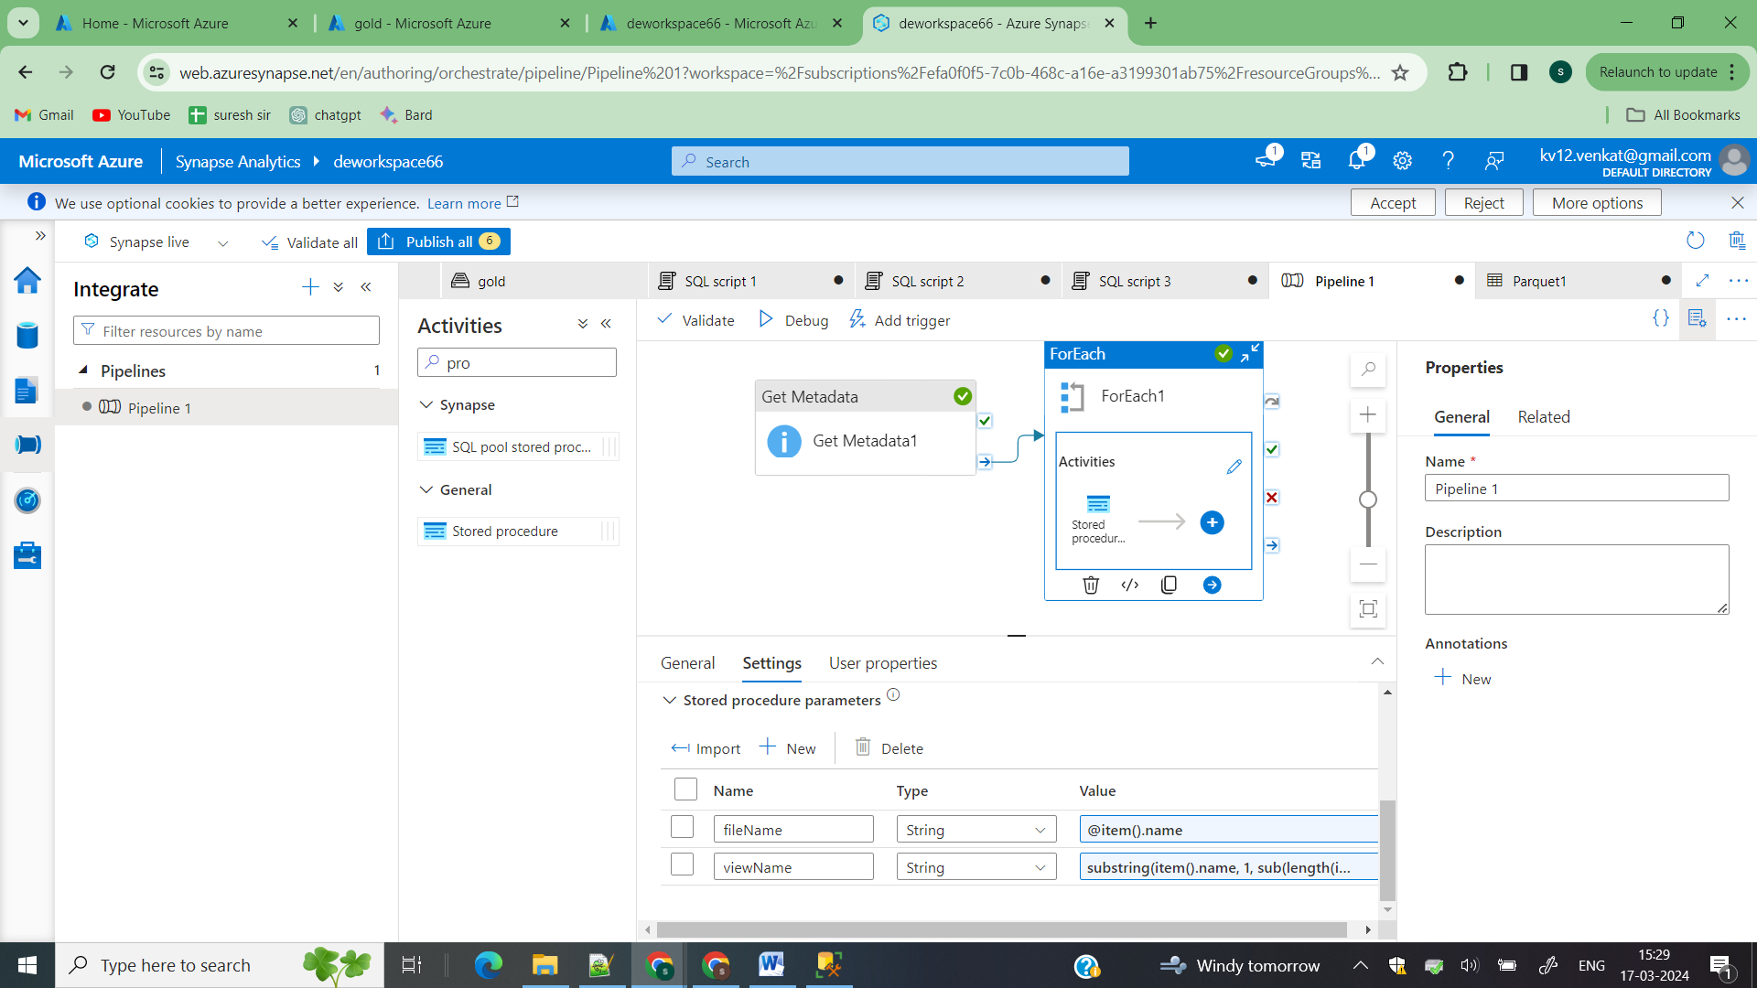

substring(item().name, 1, sub(length(item().name), 8))

Then click on trigger then in database you can see all views for your tables

Step6)

Load your synapse data to load in powerbi

<https://www.microsoft.com/en-us/download/details.aspx?id=58494>

Download powerBi desktop into your local system

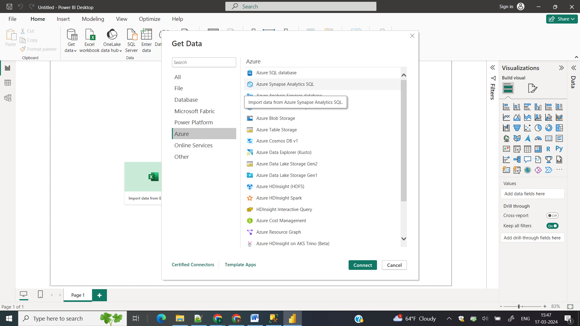

Click on getData->Azure->select Azure synapse -> Enter serverless endpoint available in properties of your synapse and give your database name and select import so the complete data will be loaded onto powerbi click on next

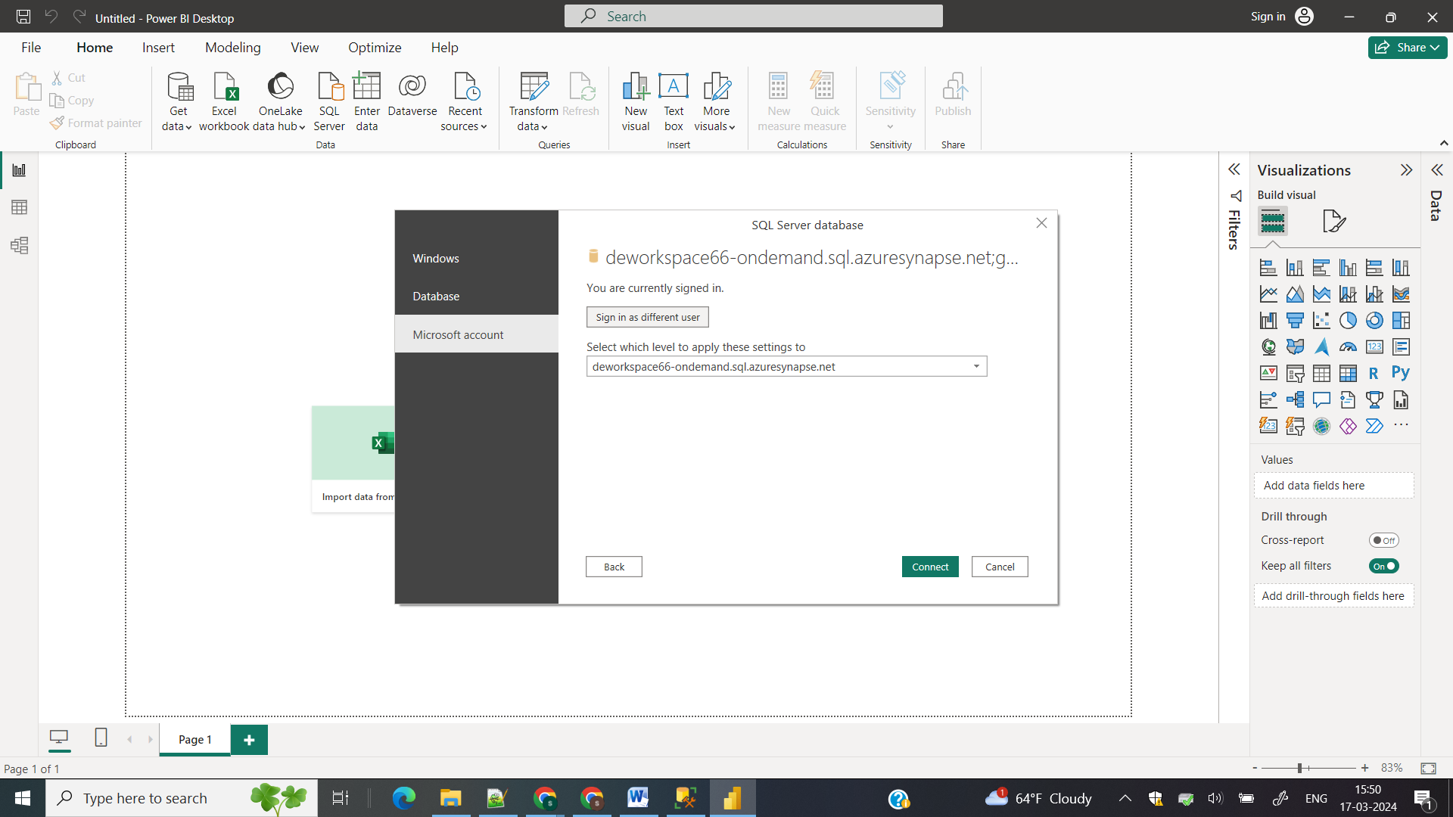

Sign in with your azure account and click on connect

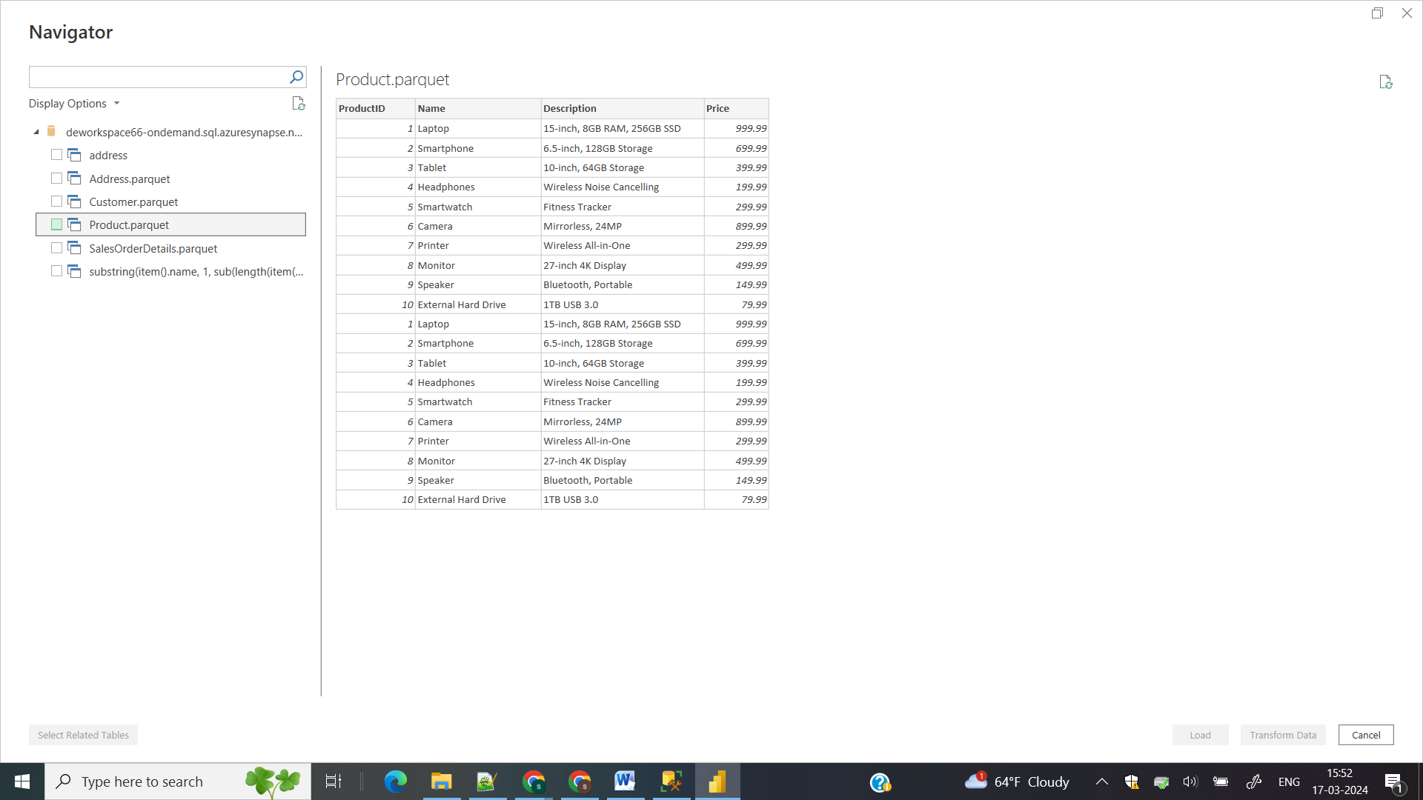 So you will get your data loaded in to your powerBI and you can perform your reposting